Principal | AL IMAN Company
Commodity description | wheat straw
Bill of Lading
Notify Party
Quantity | 870 Bales (15 Containers)
Place of inspection | First industrial zone, Badr city,Cairo

In accordance with instructions received from our principal, Al-Eiman Co. for import and export., we performed the loading inspection of the above-mentioned consignment, for which we hereby report the following:

TIME LOG

Event |  | Date | Time
SGS surveyor arrived | 1st day of inspection/loading | 12/10/2023 | 9:00 hrs
Containers inspection & Loading commenced |  | 12/10/2023 | 10:30 hrs
Containers inspection & Loading completed |  | 12/10/2023 | 12:30 hrs
SGS surveyor Left |  | 12/10/2023 | 23:30 hrs

PACKING INSPECTION

The product was found to be packed in 870 Bales.

VISUAL INSPECTION - COMPARTMENTS
We performed the visual inspection of the compartment(s) of the shipped containers & cargo bales and report the following:

Object reference |  | Date | From | To | Inspection Result
1 | CSYU403464-0 | 12/10/2023 | 10:00 hrs | 22:30 hrs | Based on a visual inspection of visibly accessible parts of the compartment(s) for cleanliness only, we found them empty, clean, dry, without sign of living infestation, without smell, apparently in good condition, free from previous cargoes as could be ascertained visually and, in these respects, only, suitable to load the above-described cargo.
2 | BEAU644816-0
3 | SEKU579045-2
4 | ASLU709492-7
5 | ASLU709640-5
6 | CSYU400952-4
7 | BEAU640104-0
8 | TGCU528203-5
9 | ASLU709441-8
10 | SEGU466731-0
11 | BEAU643750-4
12 | BEAU639533-2
13 | TGCU527442-5
14 | SEKU578963-6
15 | NNLU418052-9

TALLY

The tally inspection has been performed at Damietta port, Egypt and results was as following:

Sr. | Container number | No. Of loaded bales/container | Net Weight as Per El-Sherouk Scales Figure at Damietta Port | Date of loading
1 | CSYU403464-0 | 58 |  | 12/10/2023
2 | BEAU644816-0 | 58 |  | 12/10/2023
3 | SEKU579045-2 | 58 |  | 12/10/2023
4 | ASLU709492-7 | 58 |  | 12/10/2023
5 | ASLU709640-5 | 58 |  | 12/10/2023
6 | CSYU400952-4 | 58 |  | 12/10/2023
7 | BEAU640104-0 | 58 |  | 12/10/2023
8 | TGCU528203-5 | 58 |  | 12/10/2023
9 | ASLU709441-8 | 58 |  | 12/10/2023
10 | SEGU466731-0 | 58 |  | 12/10/2023
11 | BEAU643750-4 | 58 |  | 12/10/2023
12 | BEAU639533-2 | 58 |  | 12/10/2023
13 | TGCU527442-5 | 58 |  | 12/10/2023
14 | SEKU578963-6 | 58 |  | 12/10/2023
15 | NNLU418052-9 | 58 |  | 12/10/2023
 | Total | 870 bales

PICTURES
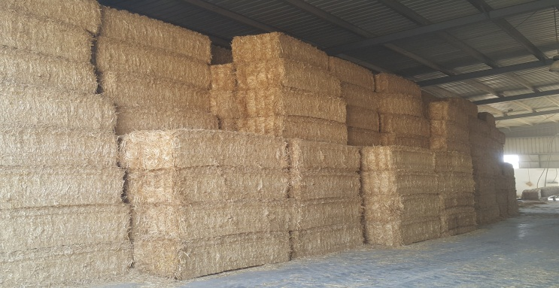 | 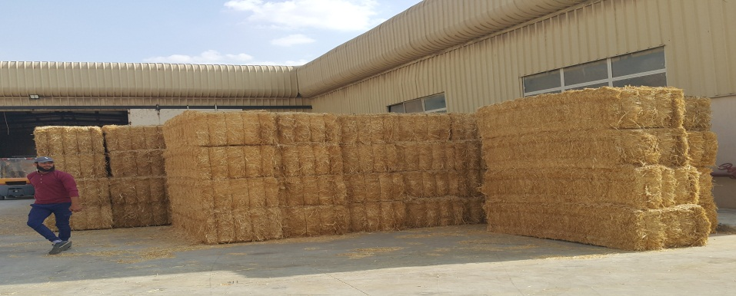
Cargo Stuffing | Cargo Stuffing
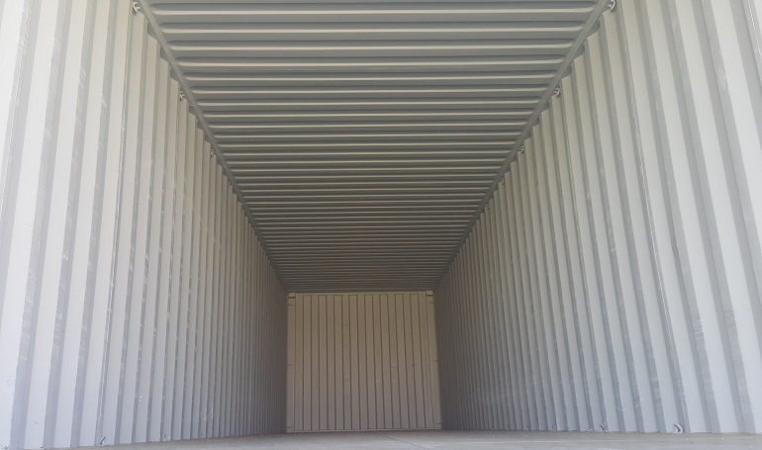  Cleanliness container inspection | 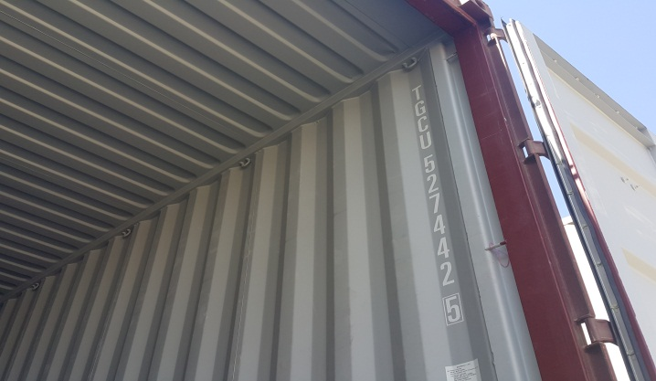  Cleanliness container inspection
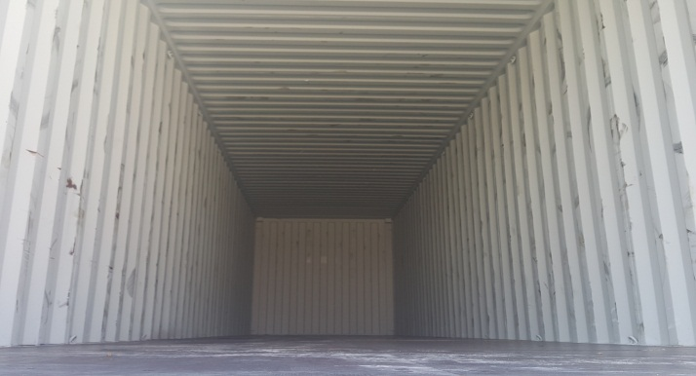  Cleanliness container inspection | 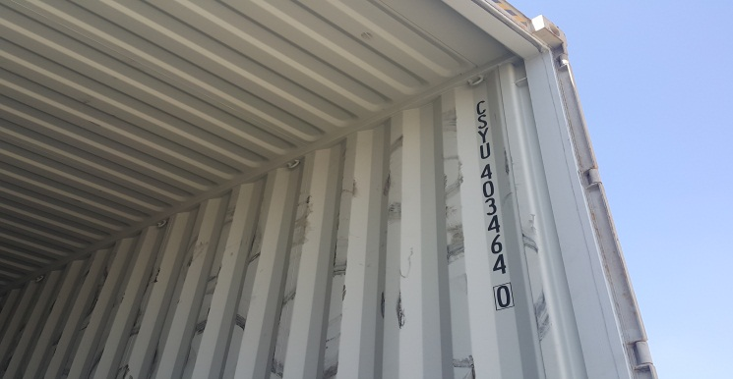Cleanliness container inspection
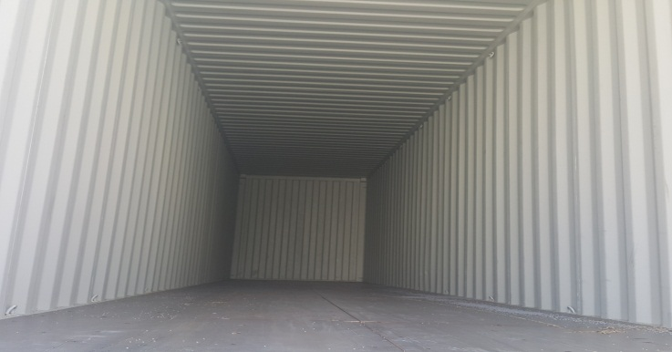 | 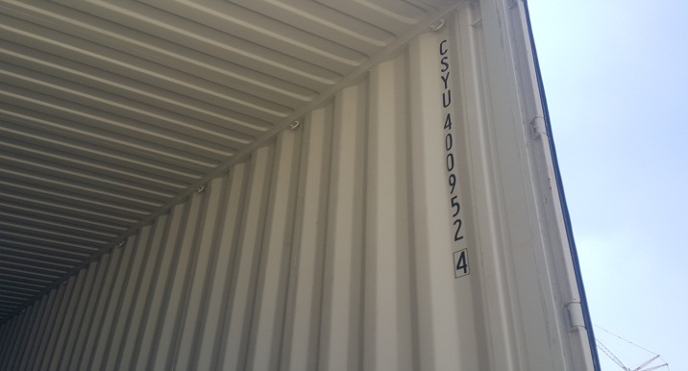
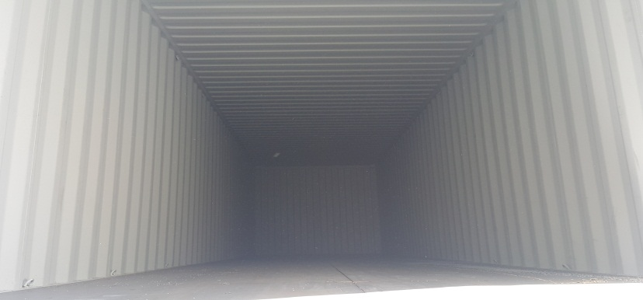Cleanliness container inspection | 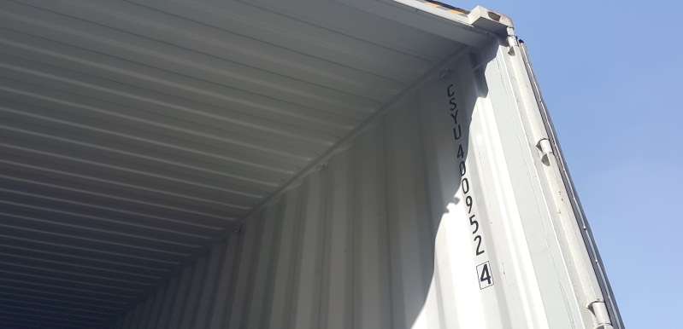Cleanliness container inspection
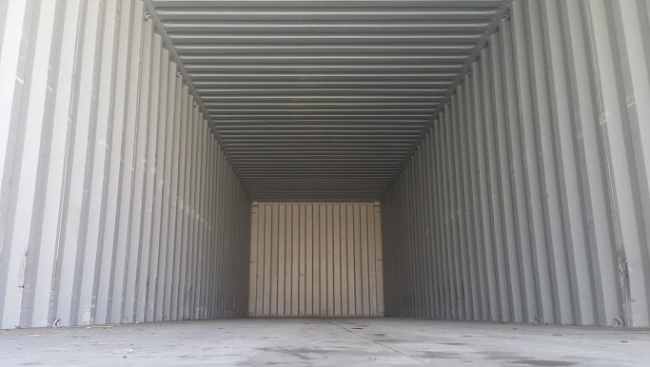 | 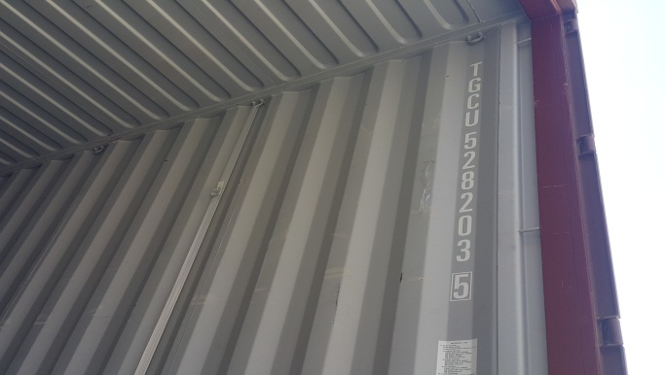
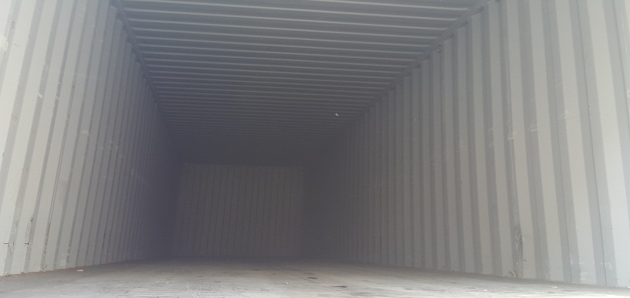Cleanliness container inspection | 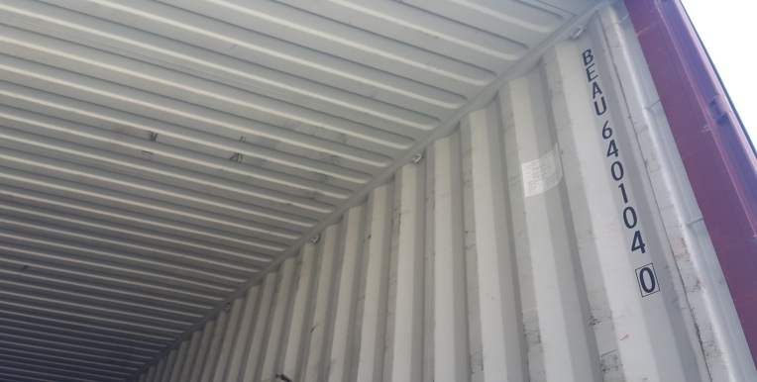Cleanliness container inspection
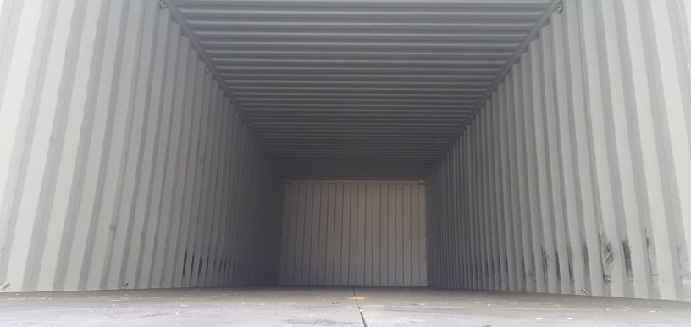Cleanliness container inspection | 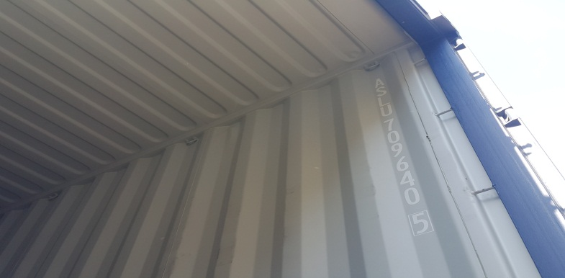Cleanliness container inspection
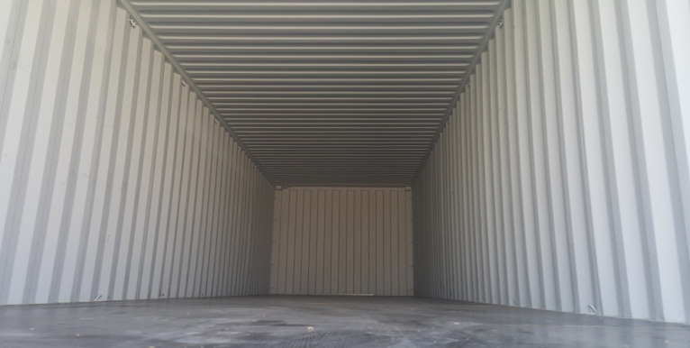  Cleanliness container inspection | 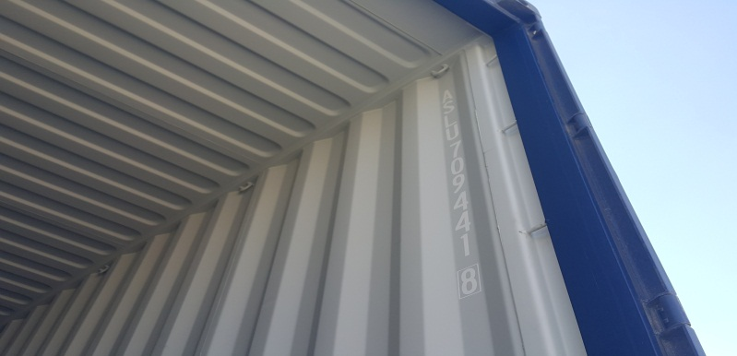  Cleanliness container inspection
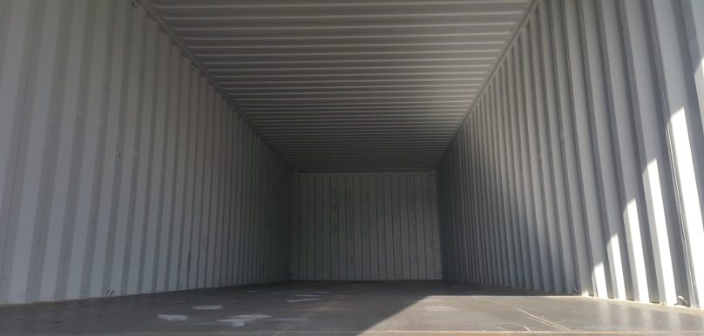Cleanliness container inspection | 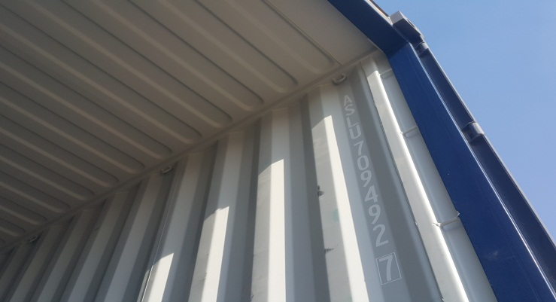  Cleanliness container inspection
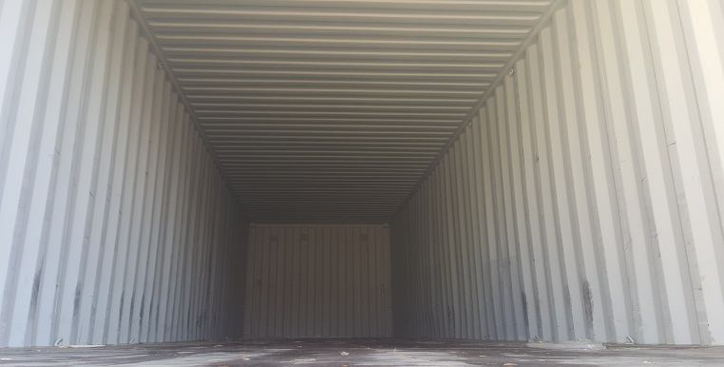 | 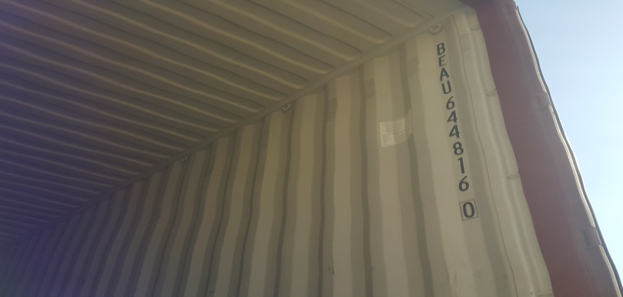
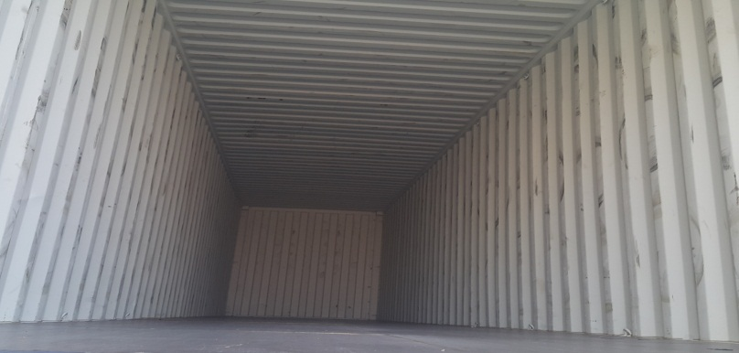Cleanliness container inspection | 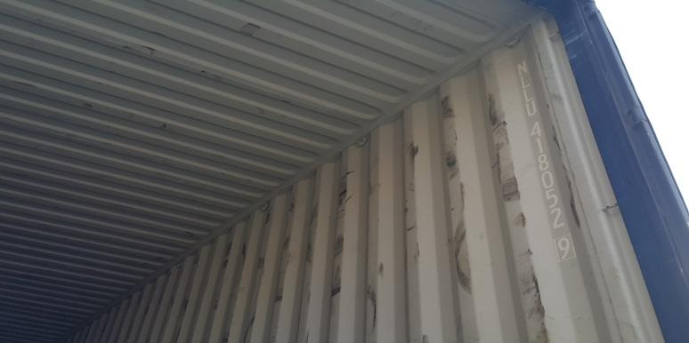Cleanliness container inspection
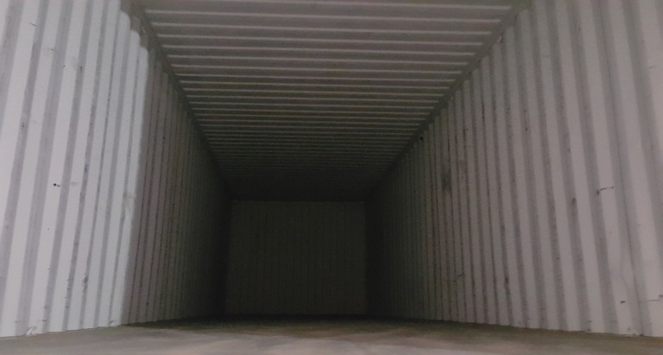  Cleanliness container inspection | 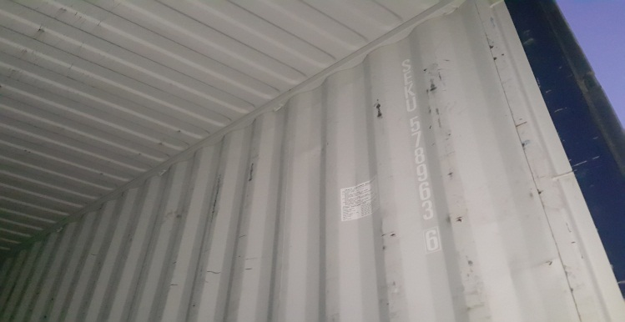Cleanliness container inspection
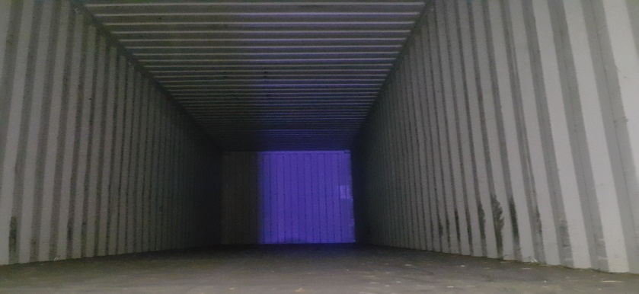Cleanliness container inspection | 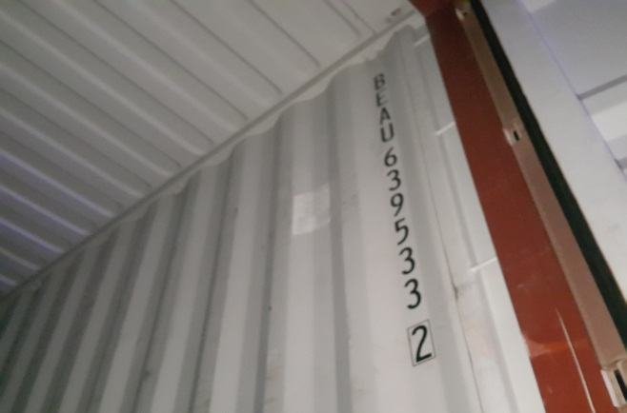  Cleanliness container inspection
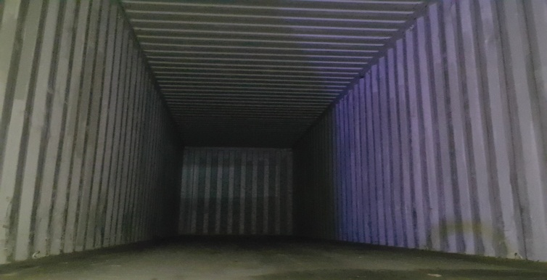  Cleanliness container inspection | 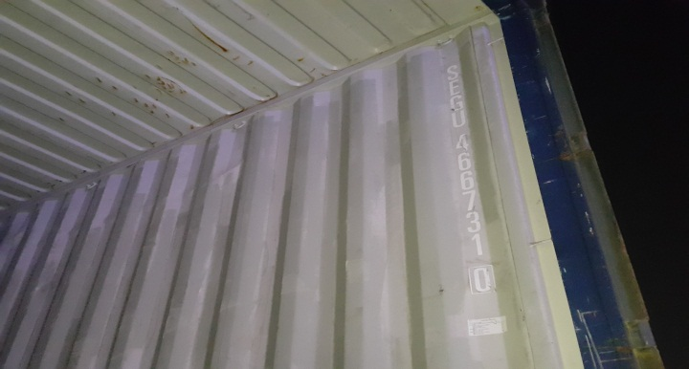  Cleanliness container inspection
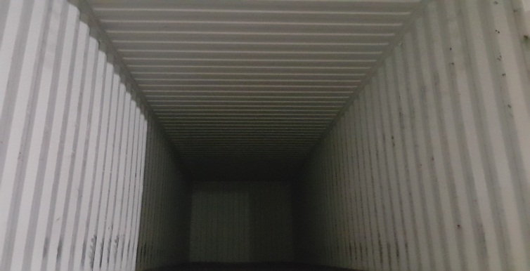 | 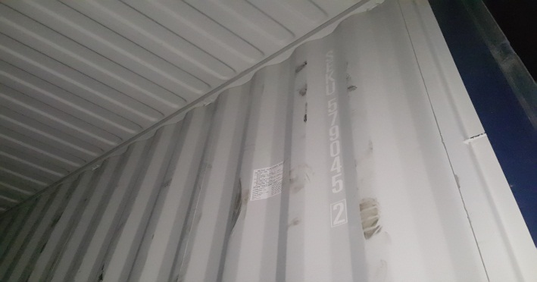
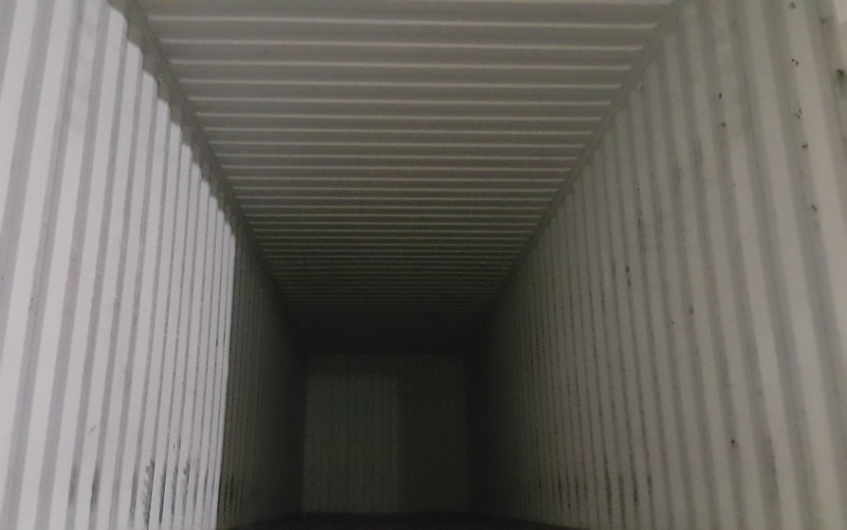  Loading Supervision | 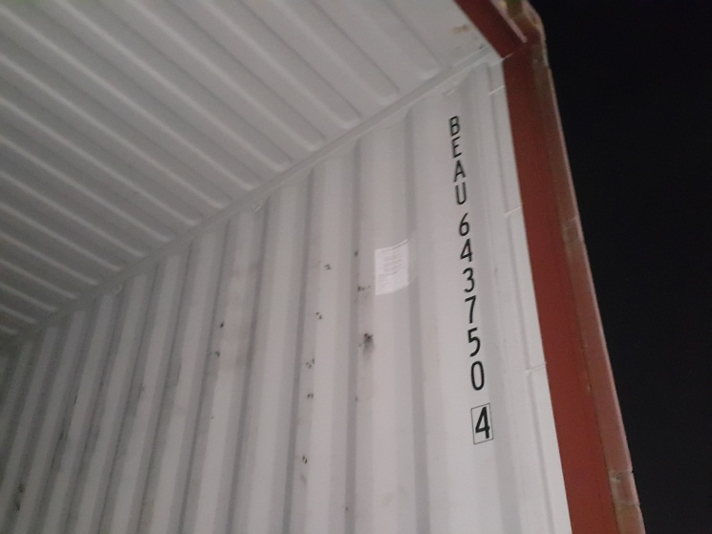  Loading Supervision
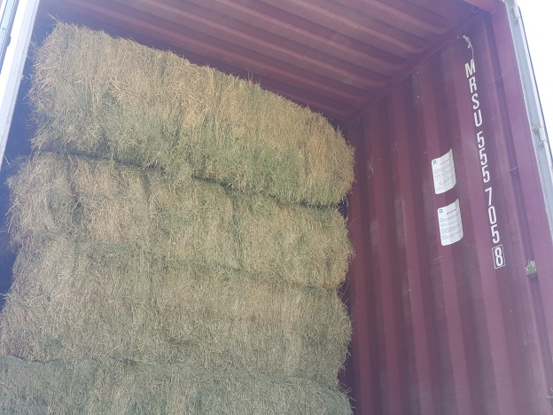 | 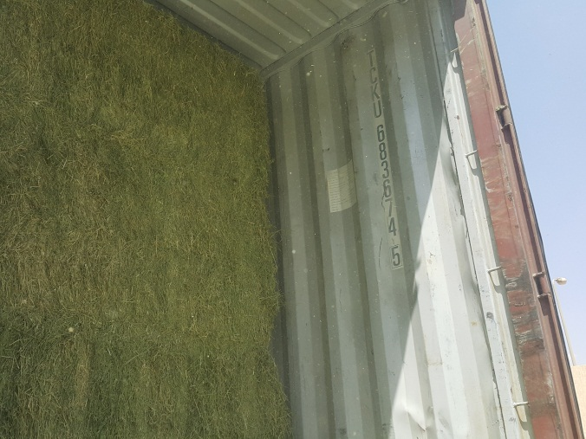
Loading Supervision | Loading Supervision
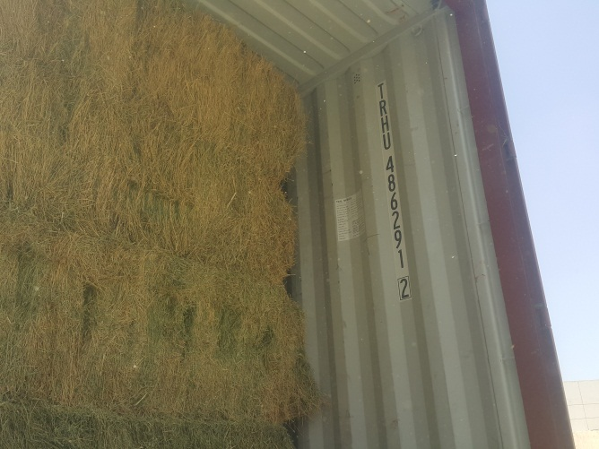  Loading Supervision | 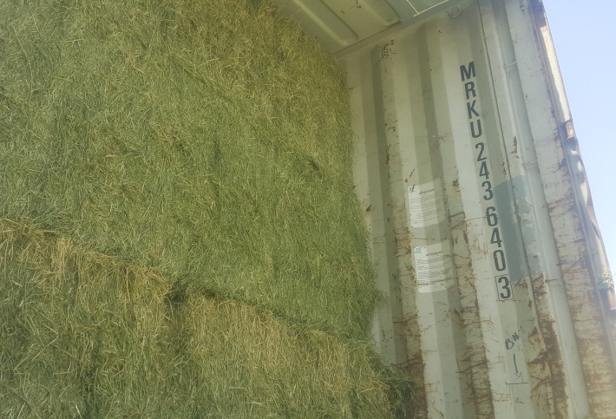  Loading Supervision
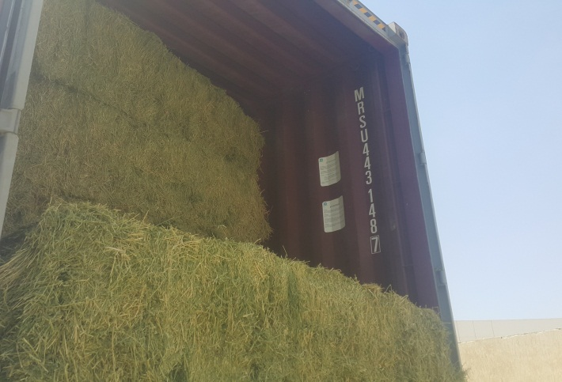  Loading Supervision | 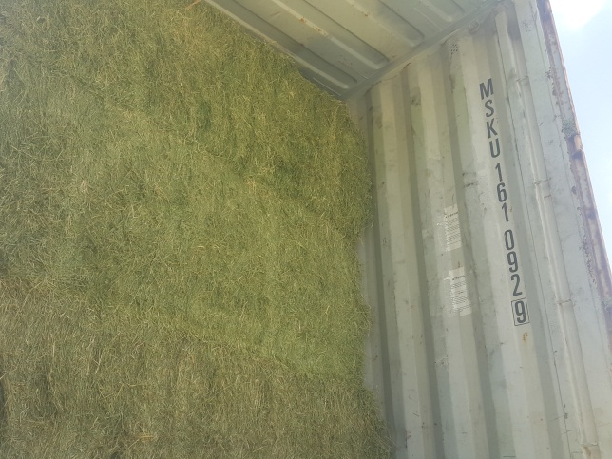  Loading Supervision
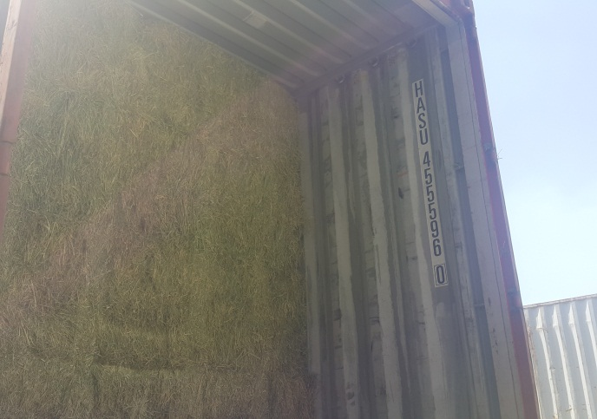  Loading Supervision | 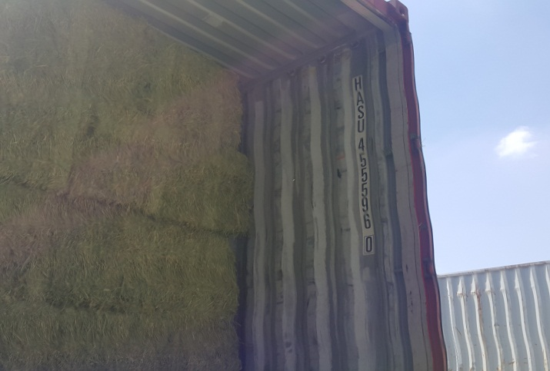  Loading Supervision
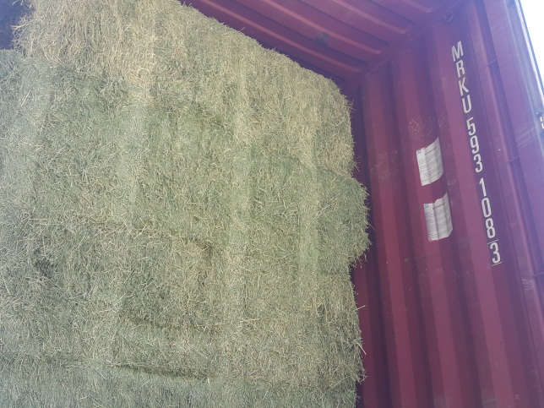  Loading Supervision | 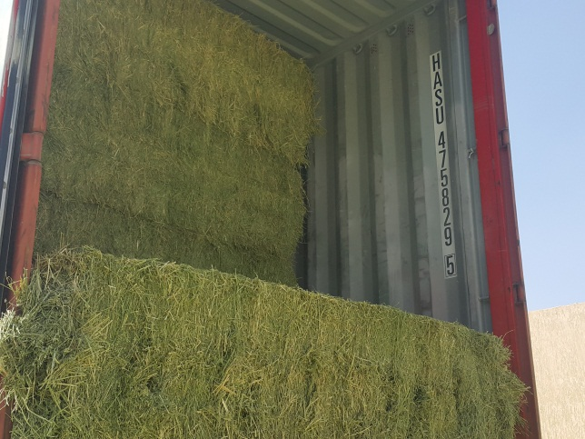  Loading Supervision
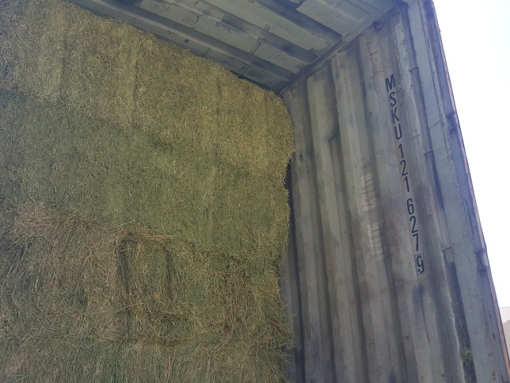  Loading Supervision | 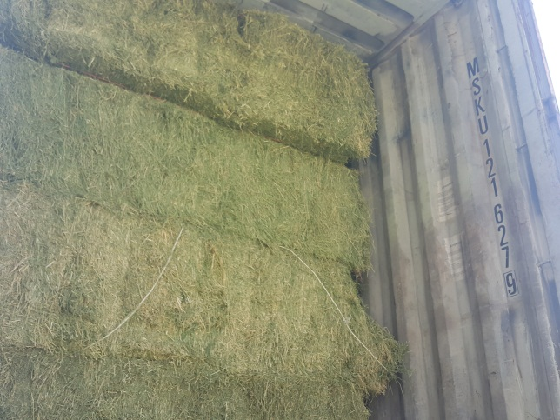  Loading Supervision
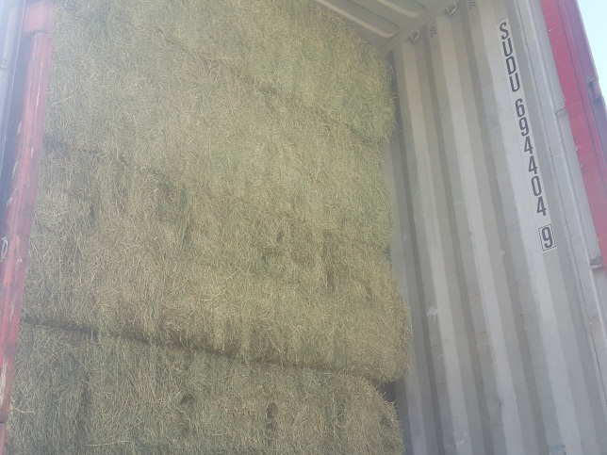  Loading Supervision | 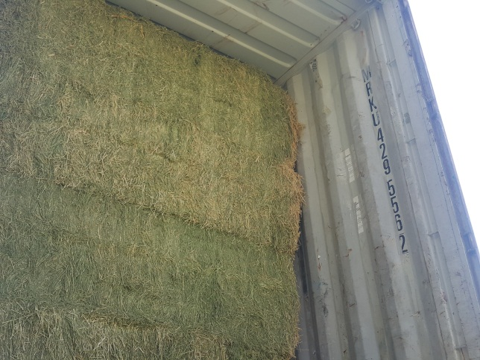  Loading Supervision
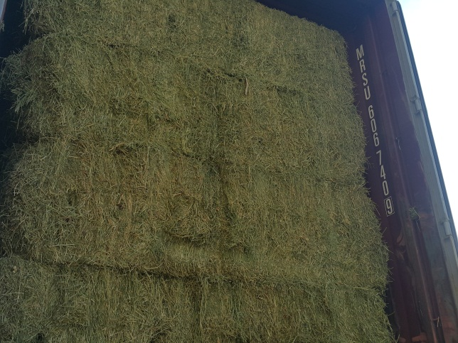  Loading Supervision | 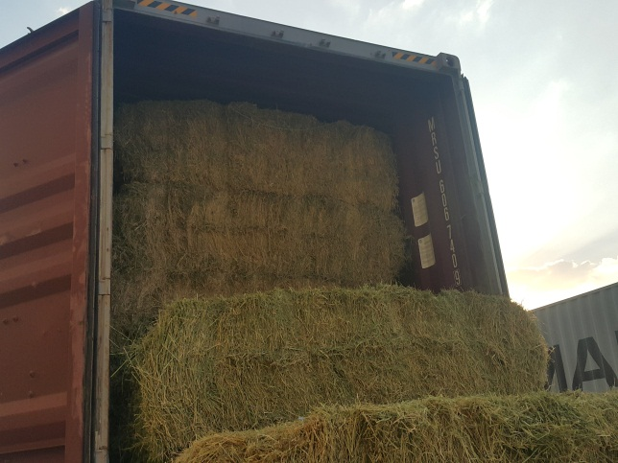  Loading Supervision
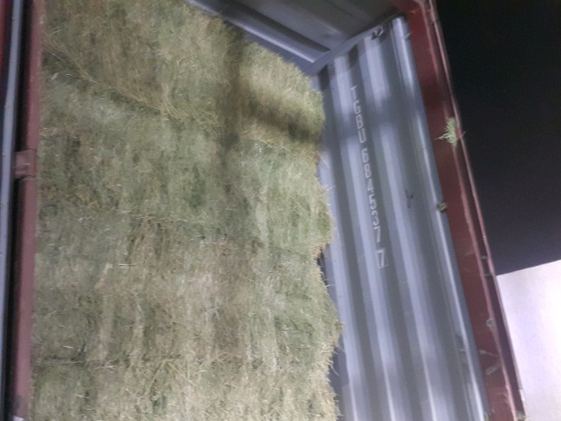  Loading Supervision | 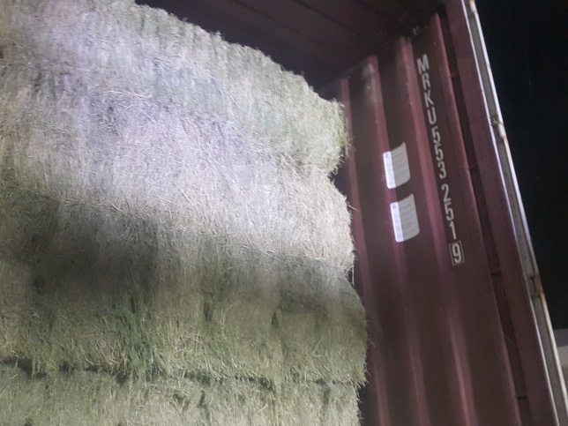  Loading Supervision
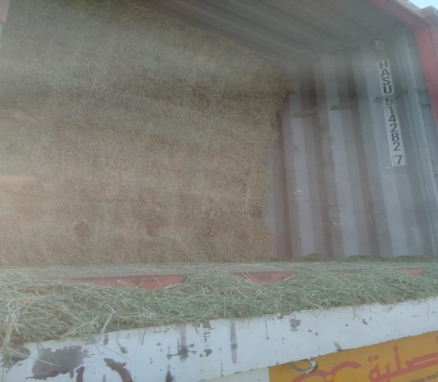  Loading Supervision | 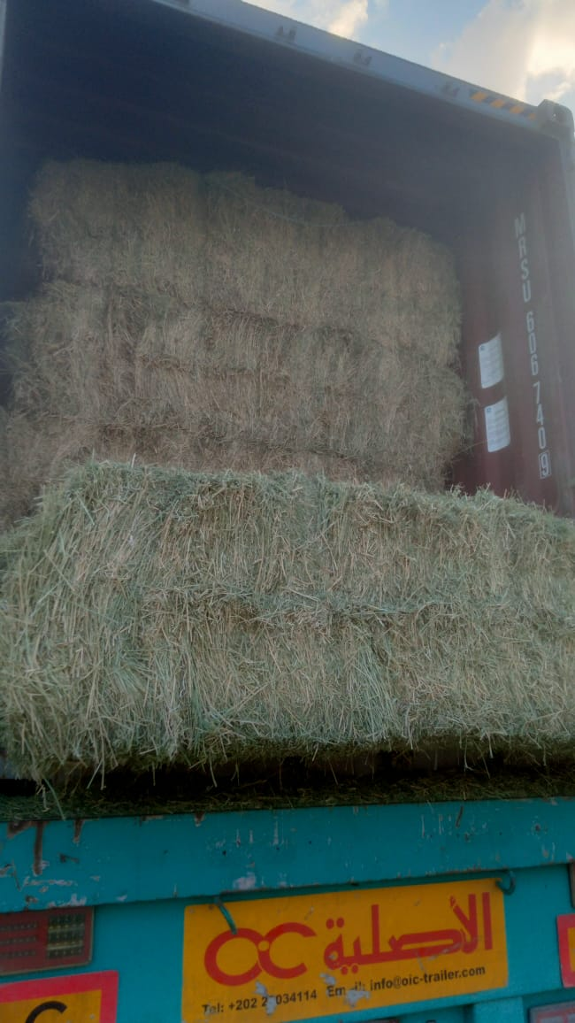  Loading Supervision
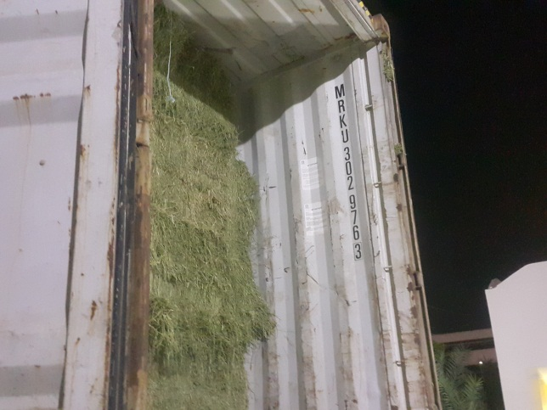  Loading Supervision | 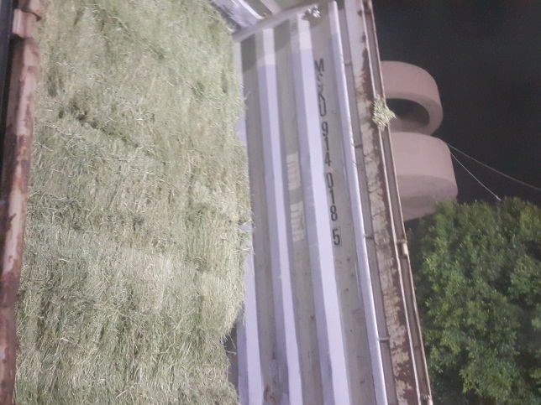  Loading Supervision
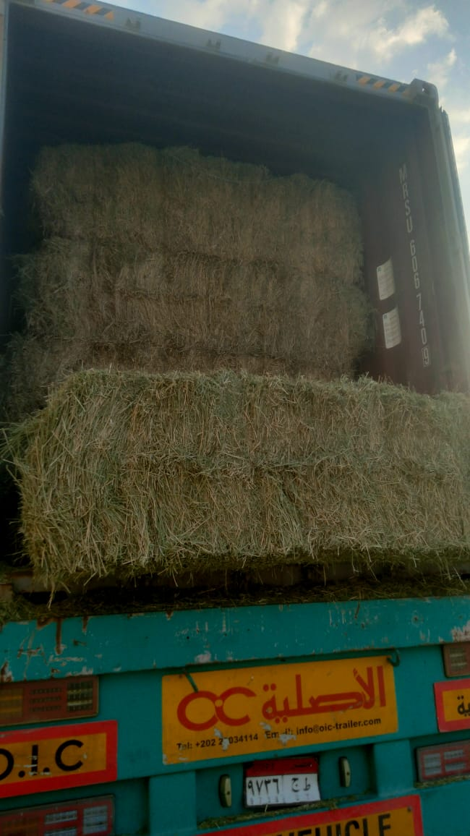  Loading Supervision | 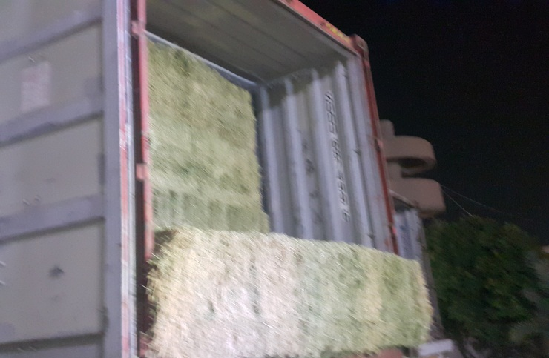  Loading Supervision
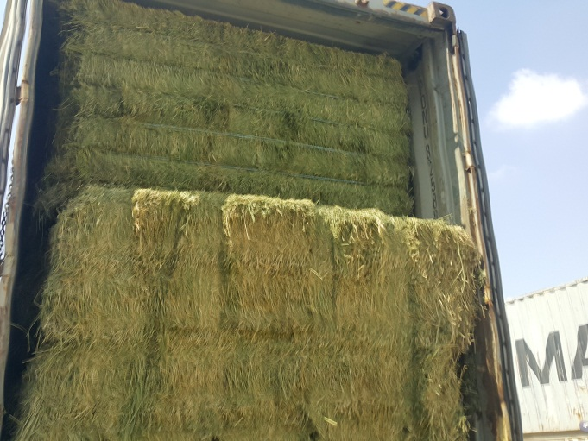 | 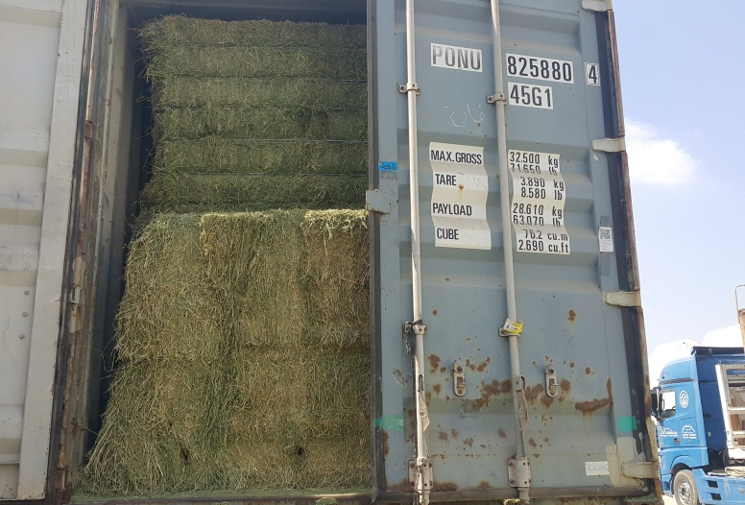
Finished Loading | Finished loading with half door
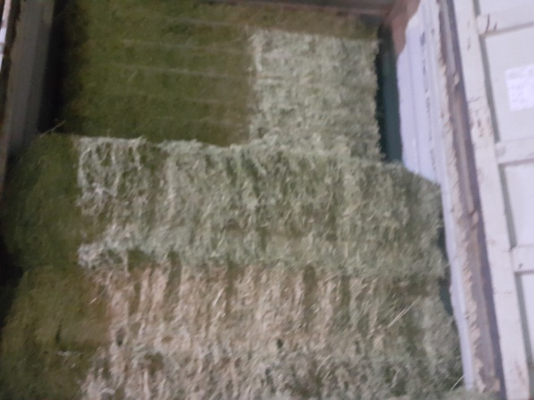 | 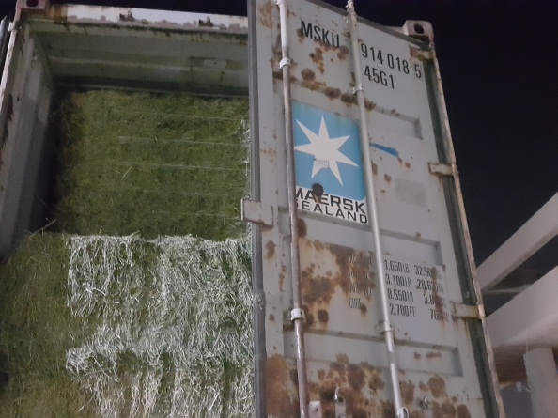
Finished Loading | Finished loading with half door
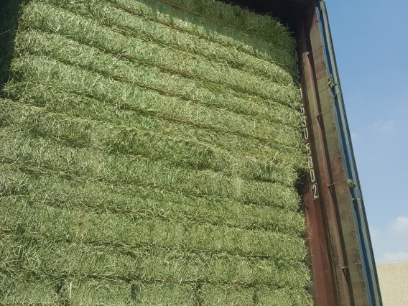 | 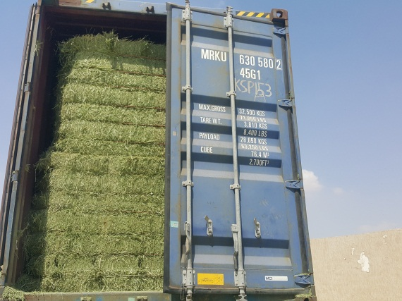
Finished Loading | Finished loading with half door
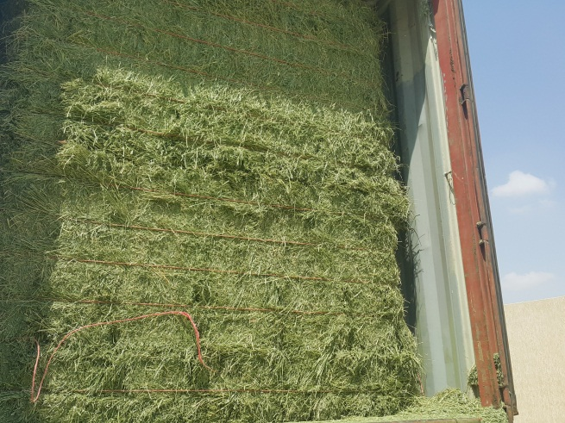 | 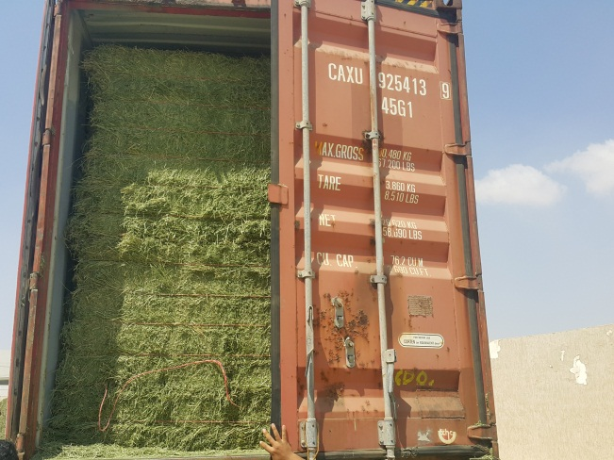
Finished Loading | Finished loading with half door
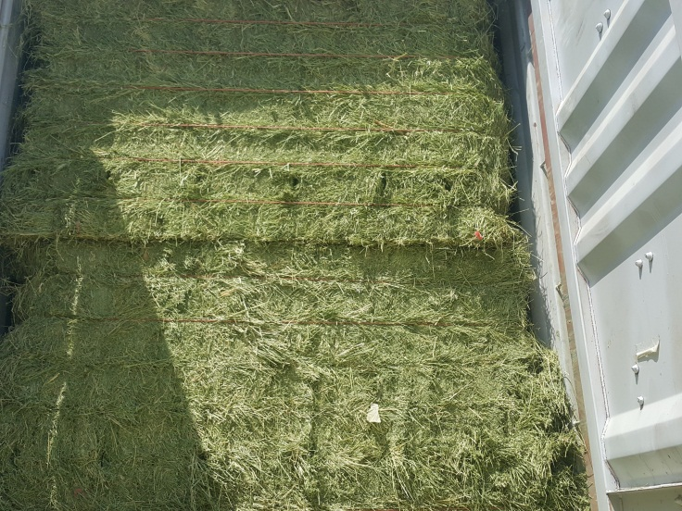  Finished Loading | 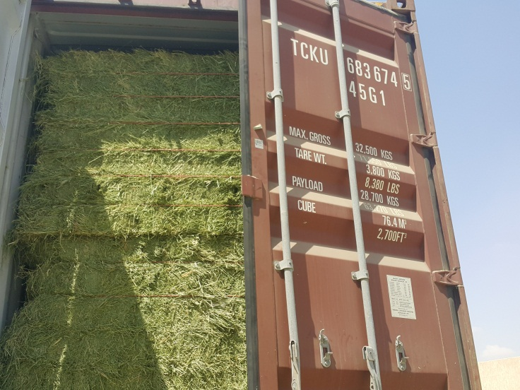  Finished loading with half door
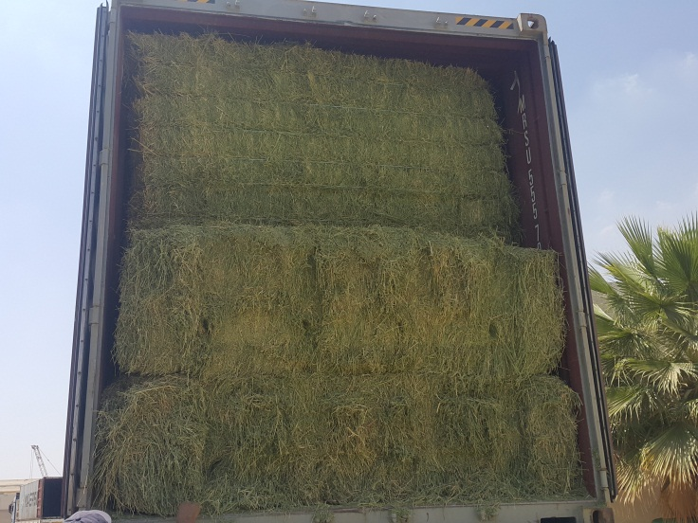  Finished Loading | 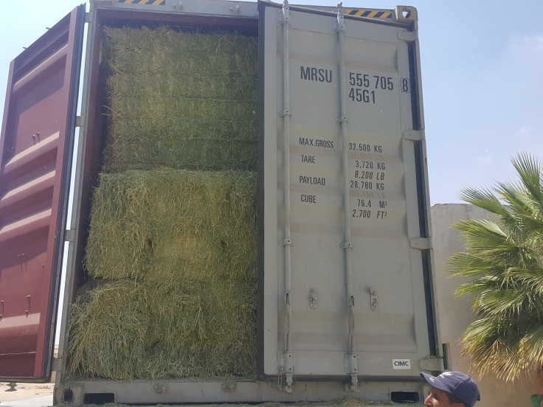  Finished loading with half door
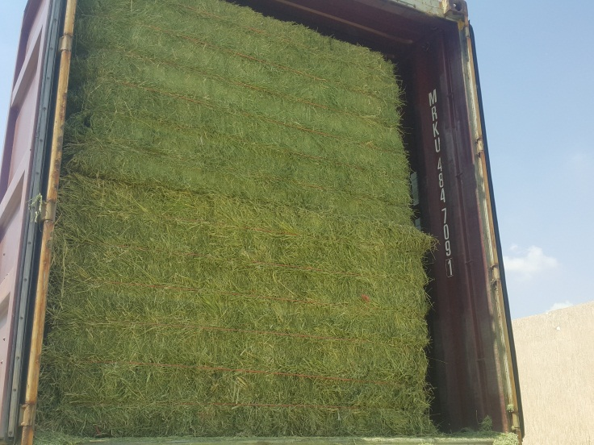  Finished Loading | 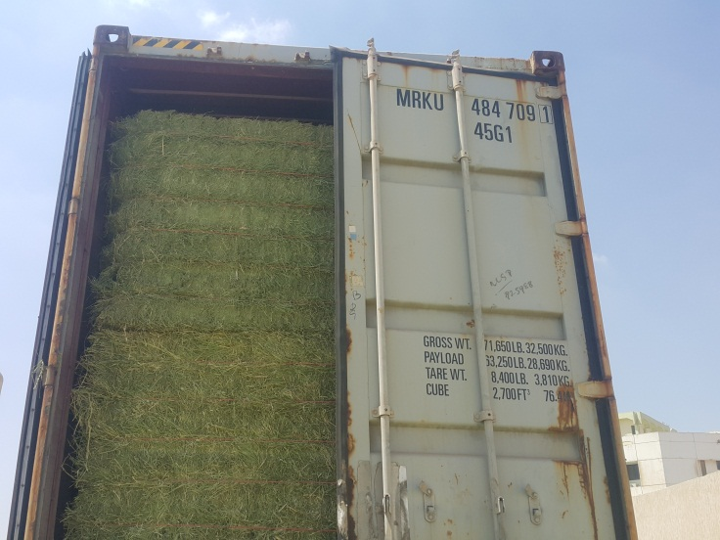  Finished loading with half door
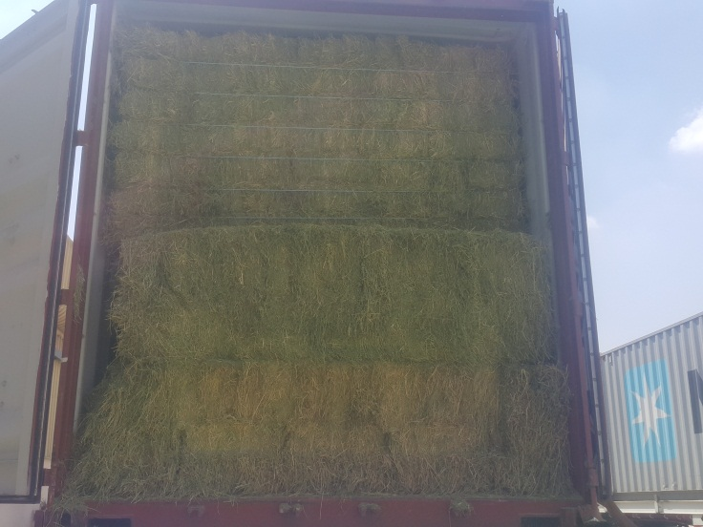  Finished Loading | 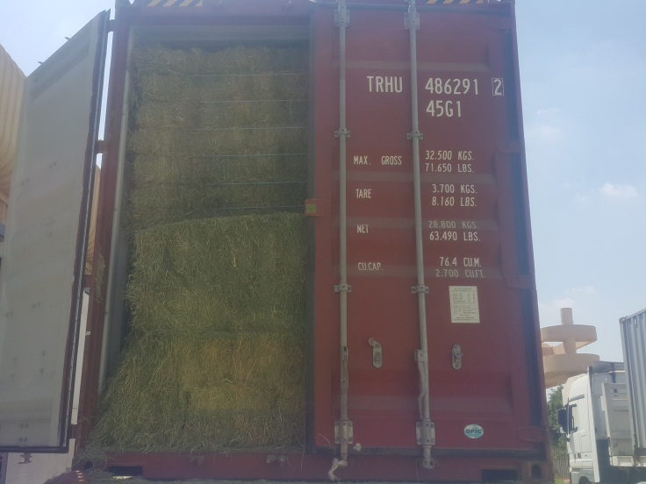  Finished loading with half door
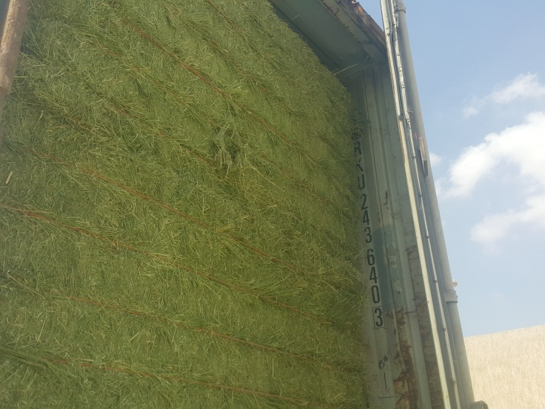  Finished Loading | 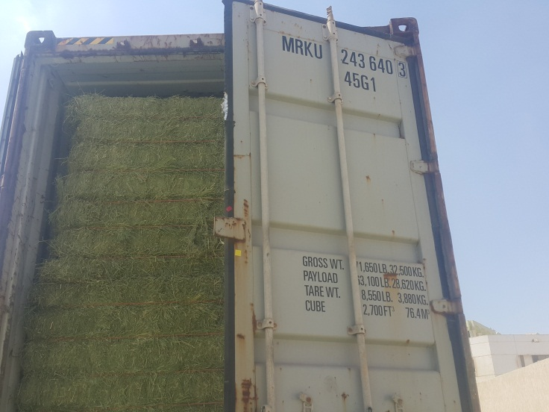  Finished loading with half door
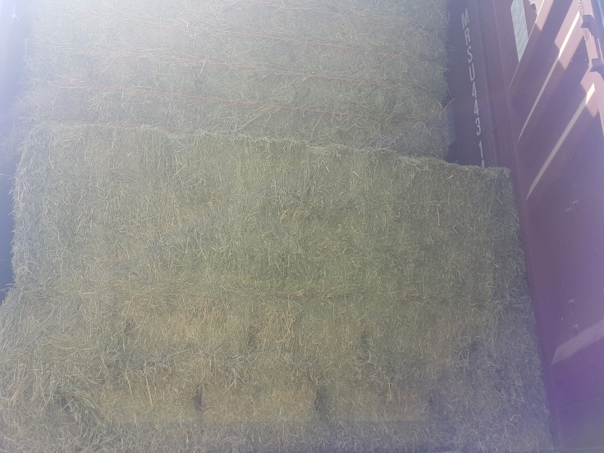  Finished Loading | 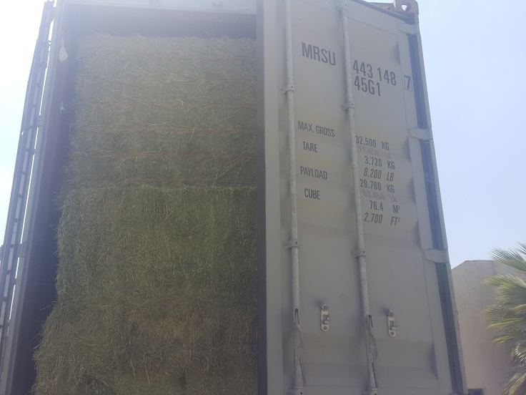  Finished loading with half door
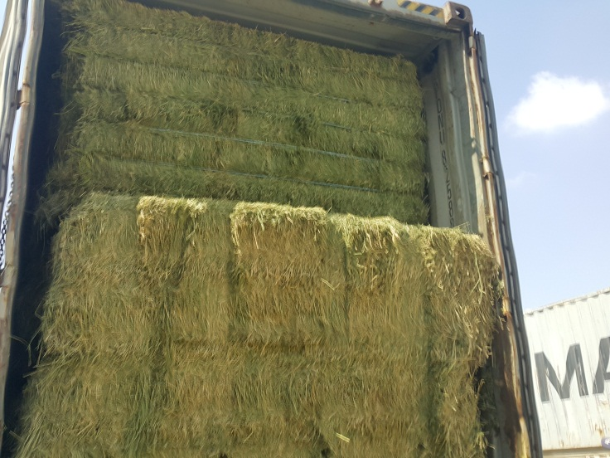  Finished Loading | 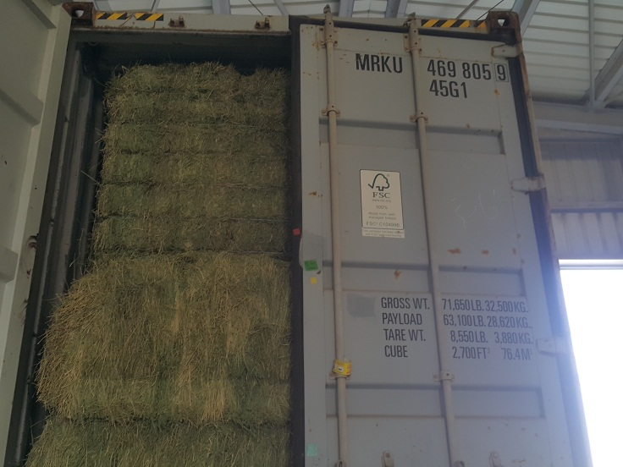  Finished loading with half door
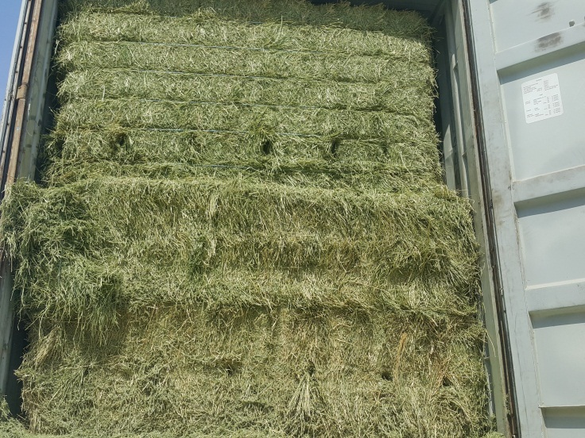  Finished Loading | 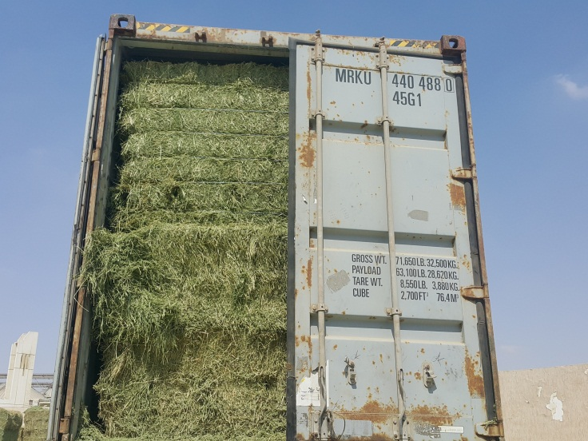  Finished loading with half door
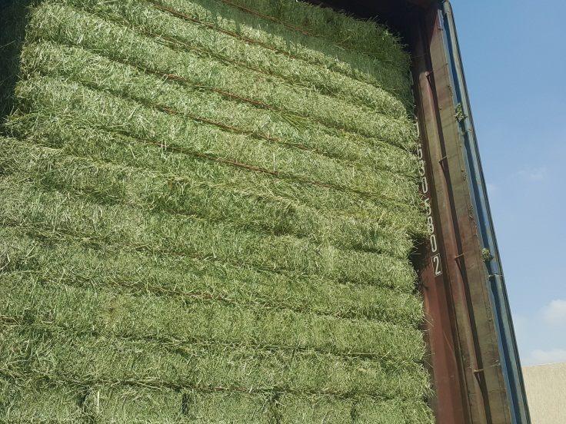  Finished Loading | 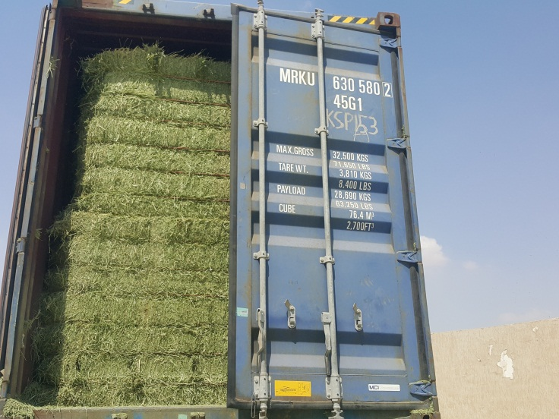  Finished loading with half door
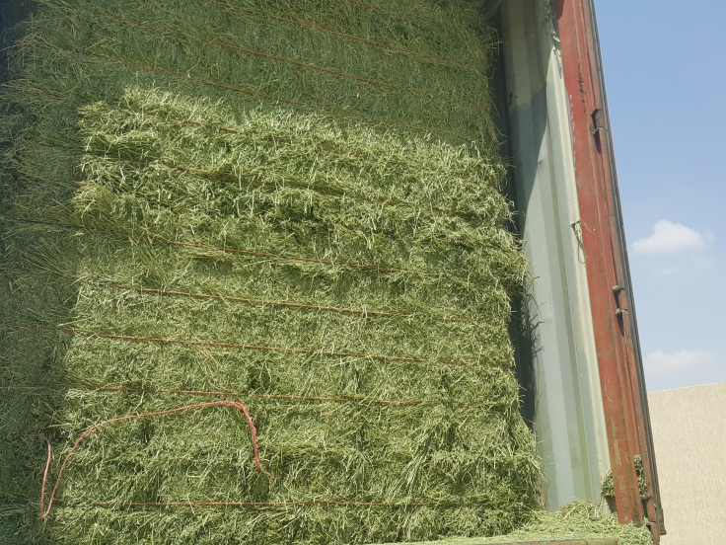  Finished Loading | 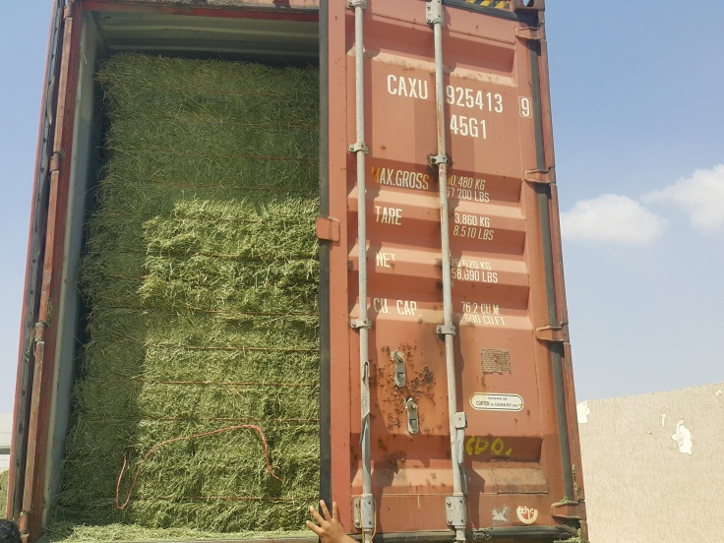  Finished loading with half door
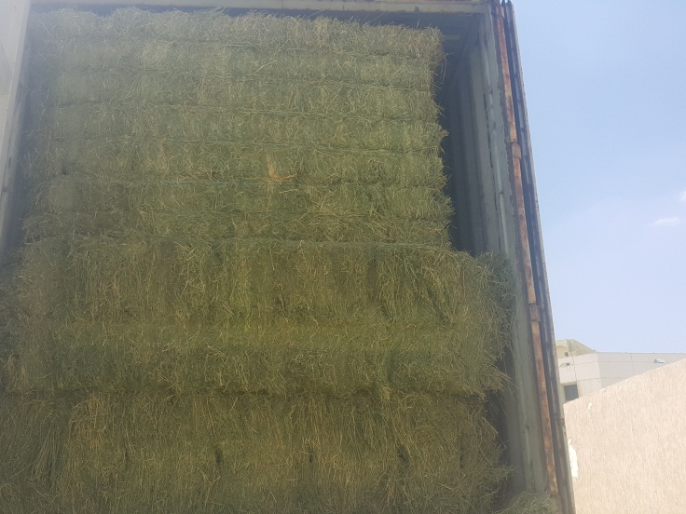 | 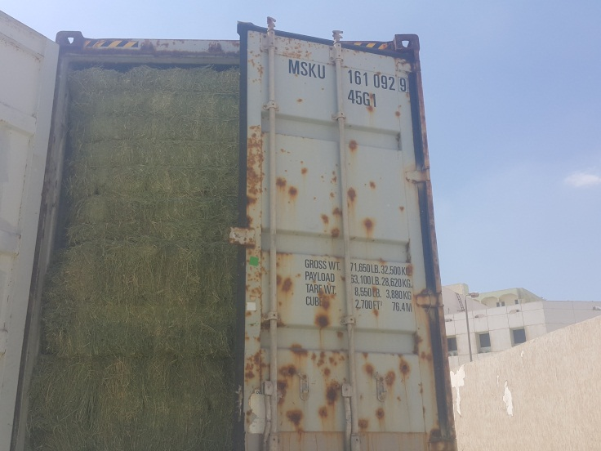
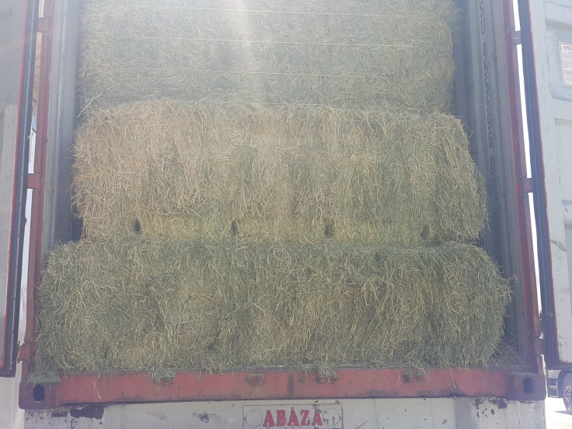  Finished Loading | 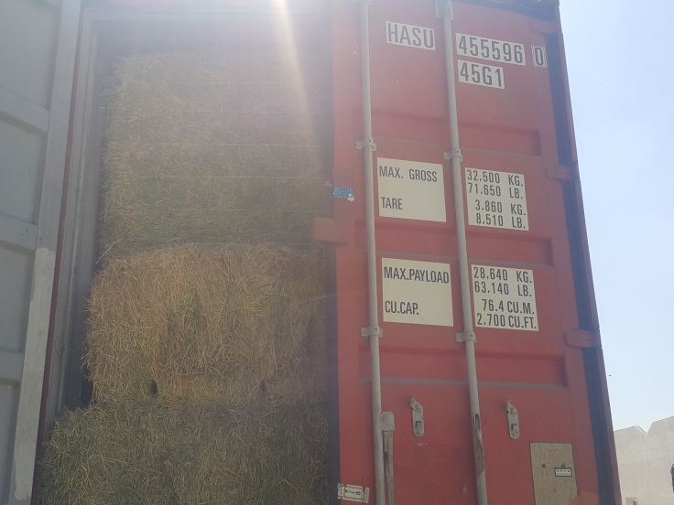  Finished loading with half door
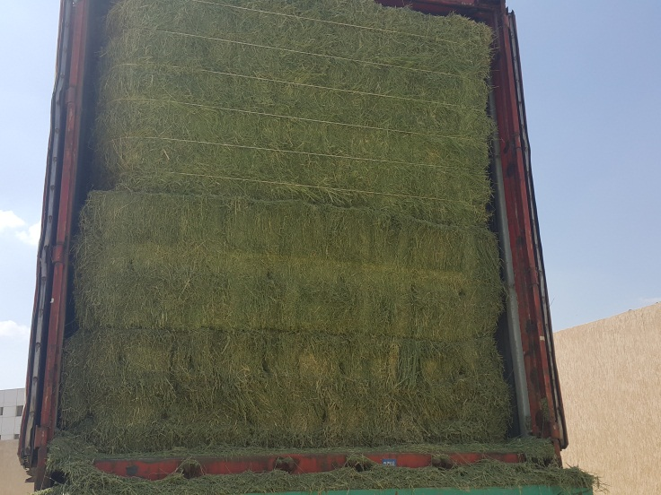  Finished Loading | 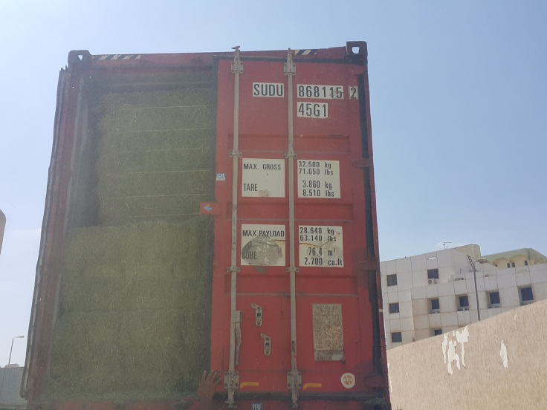  Finished loading with half door
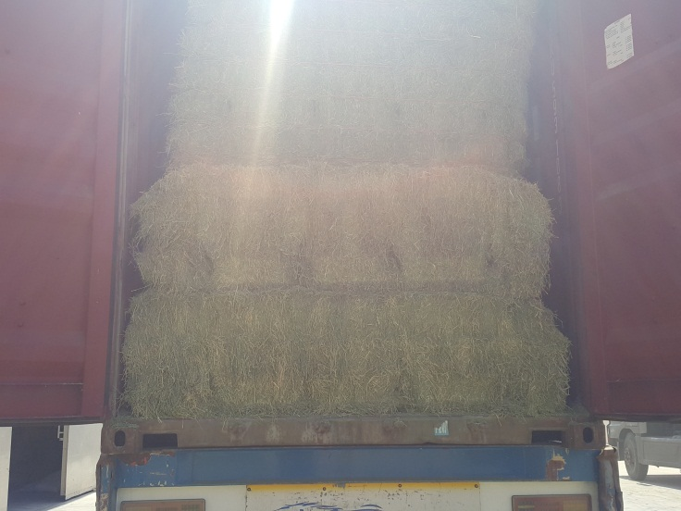  Finished Loading | 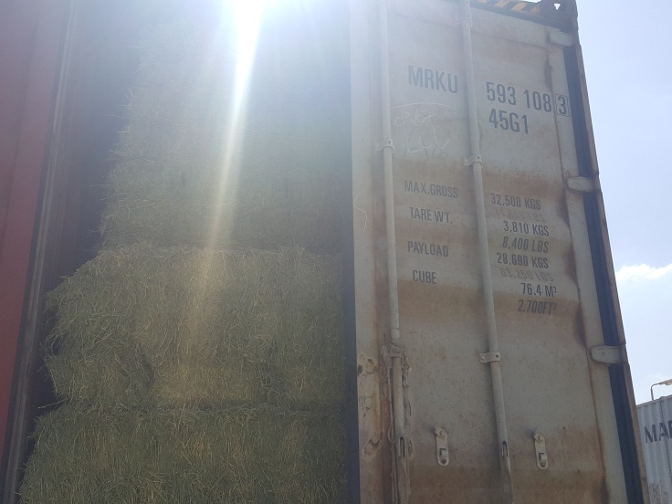  Finished loading with half door
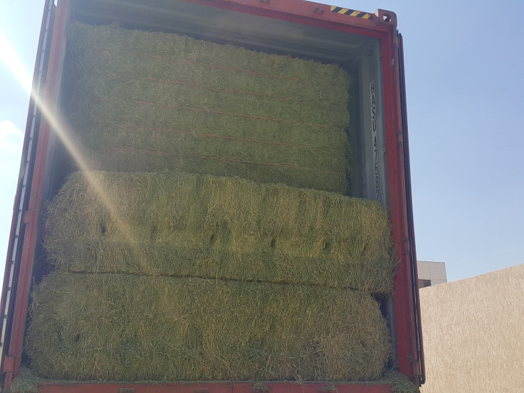  Finished Loading | 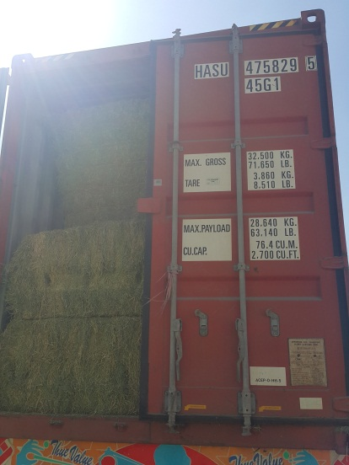  Finished loading with half door
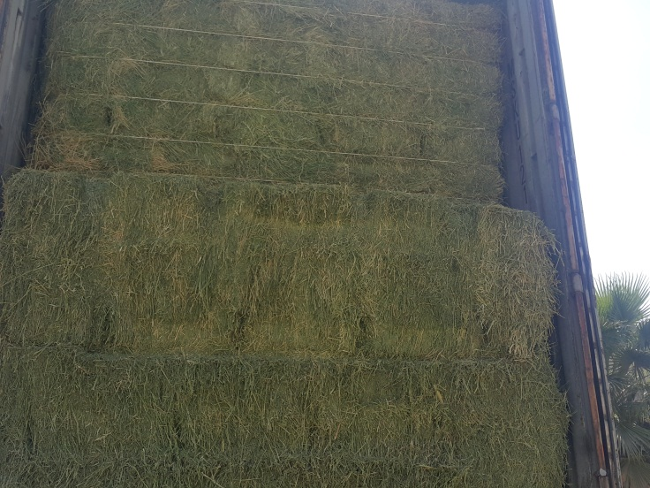  Finished Loading | 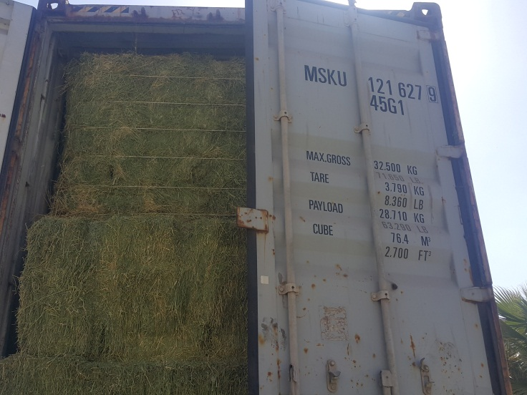  Finished loading with half door
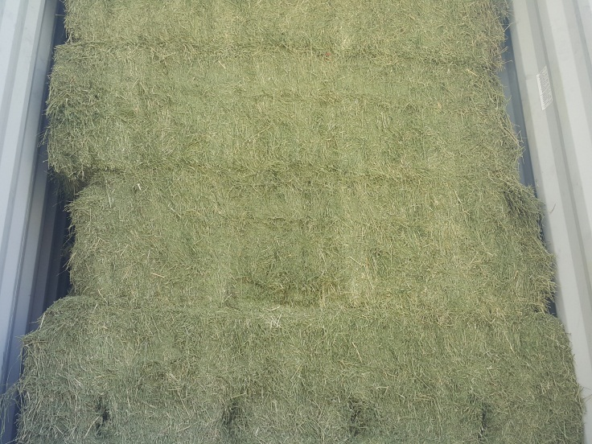  Finished Loading | 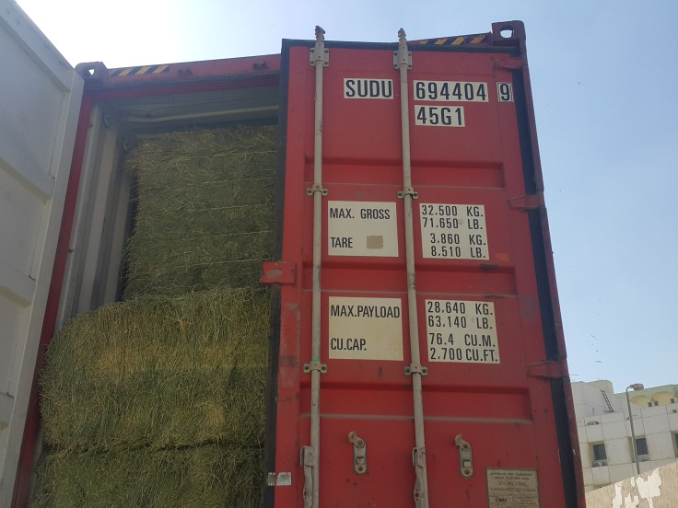  Finished loading with half door
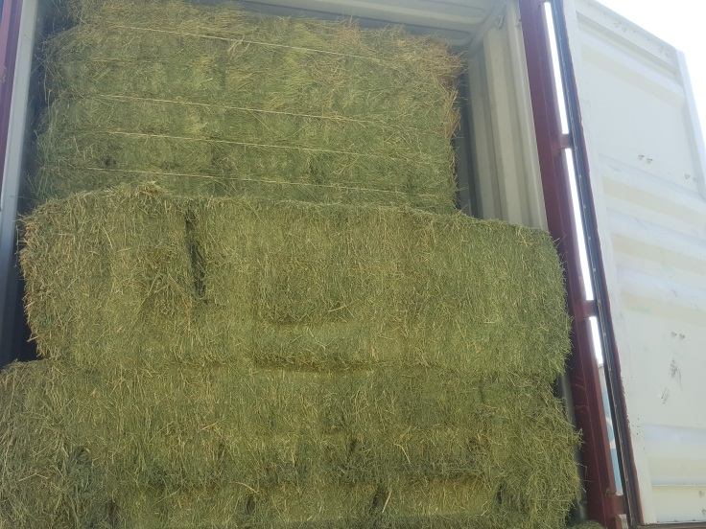  Finished Loading | 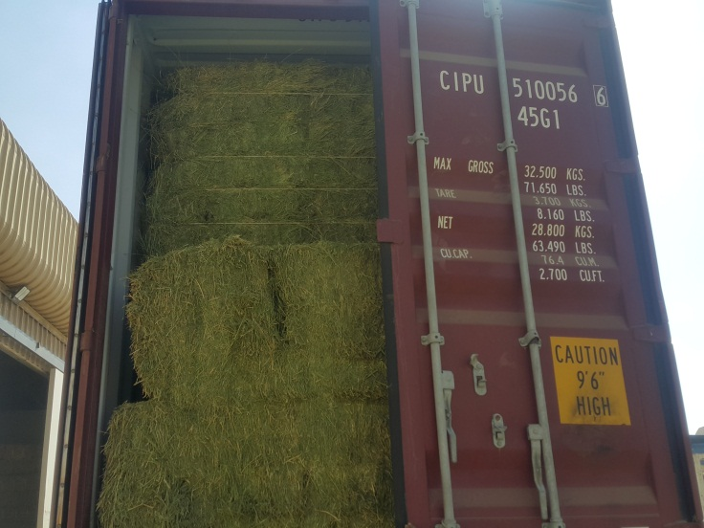  Finished loading with half door
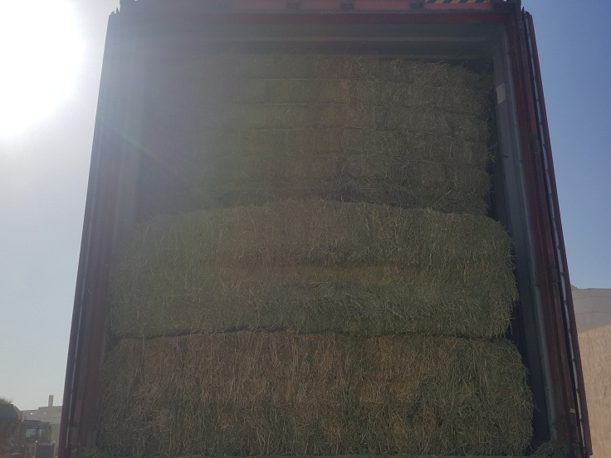  Finished Loading | 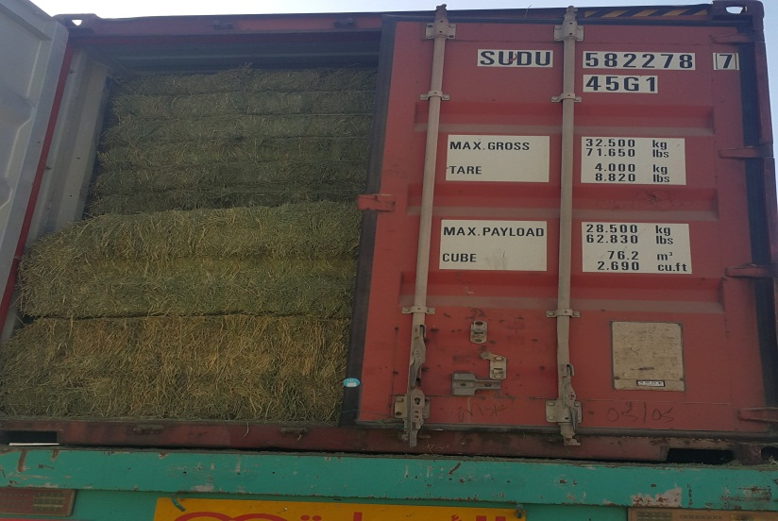  Finished loading with half door
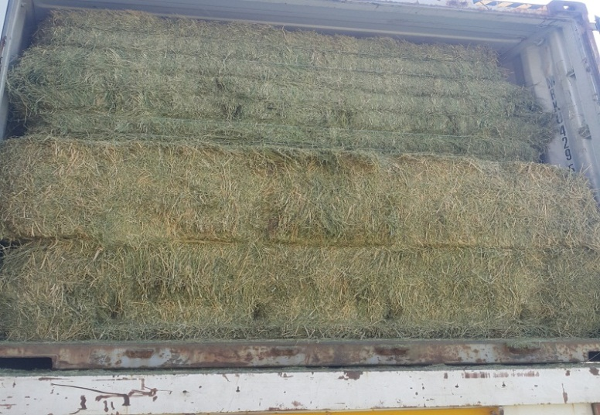  Finished Loading | 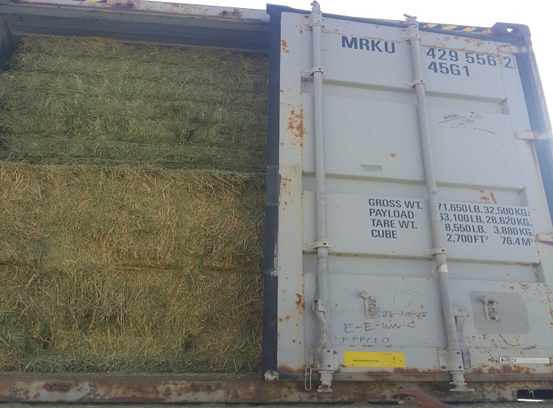  Finished loading with half door
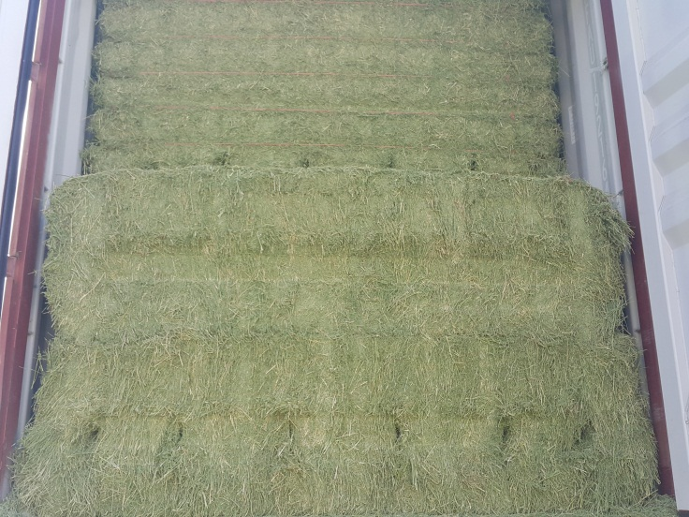  Finished Loading | 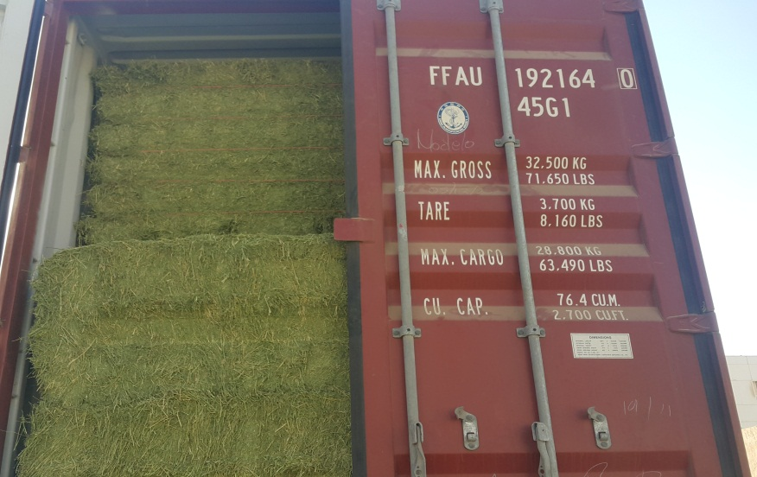  Finished loading with half door
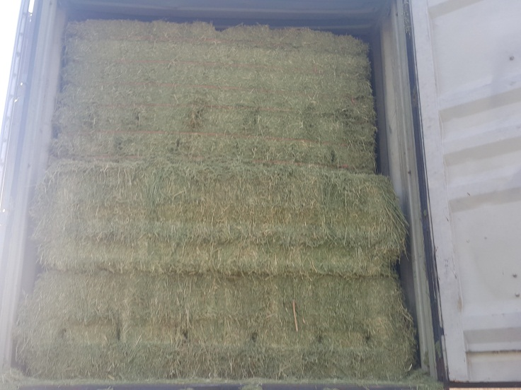  Finished Loading | 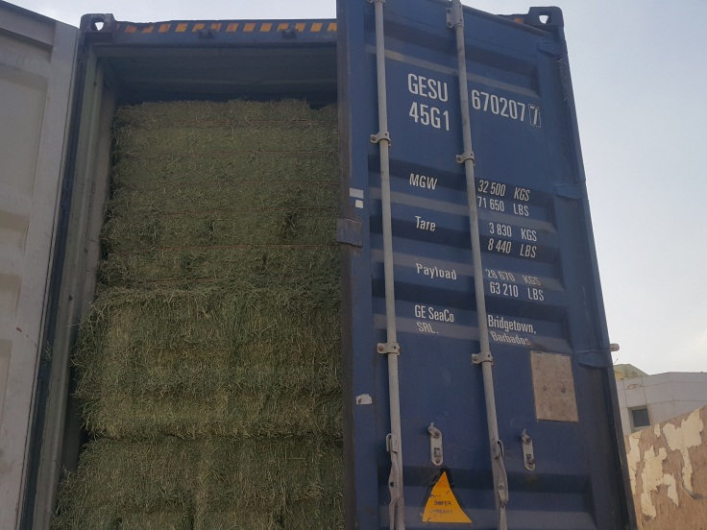  Finished loading with half door
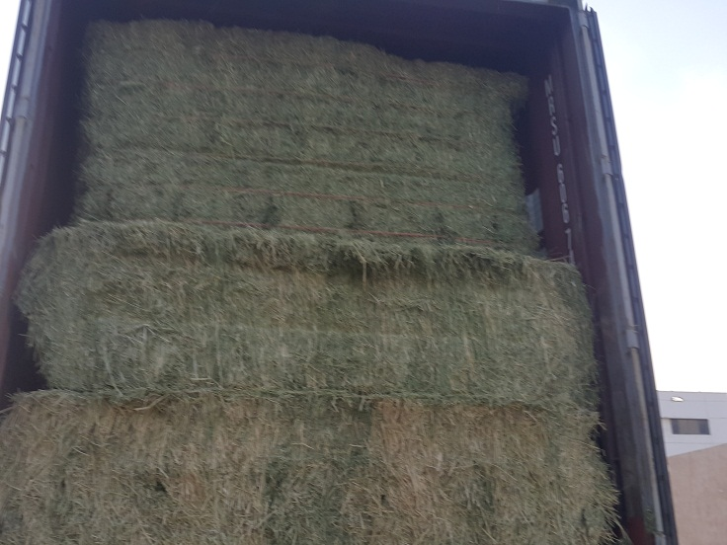  Finished Loading | 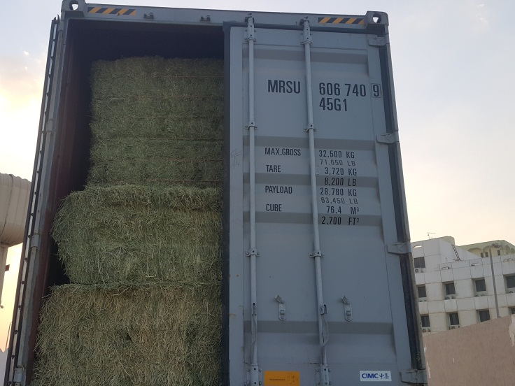  Finished loading with half door
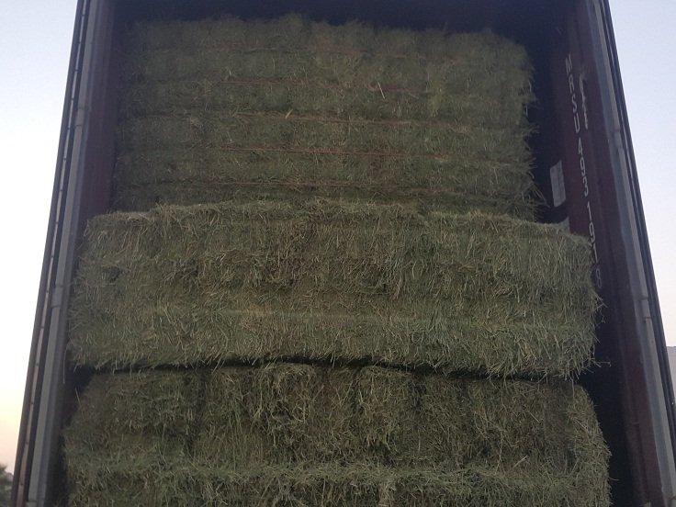  Finished Loading | 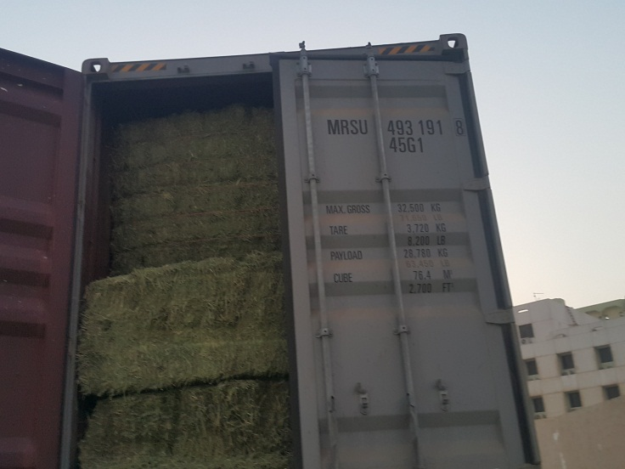  Finished loading with half door
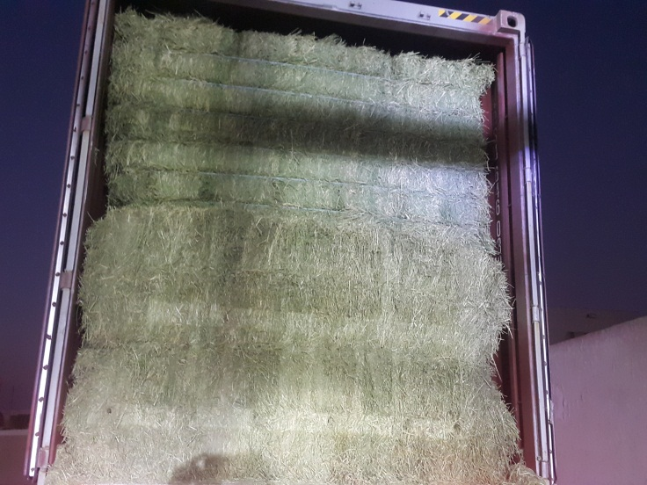  Finished Loading | 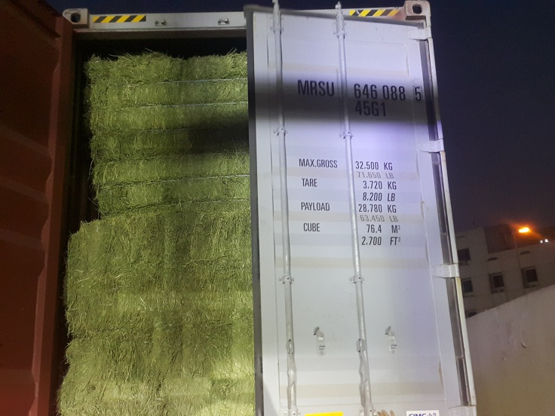  Finished loading with half door
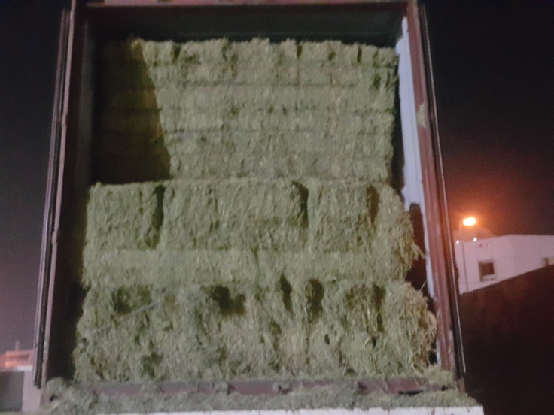  Finished Loading | 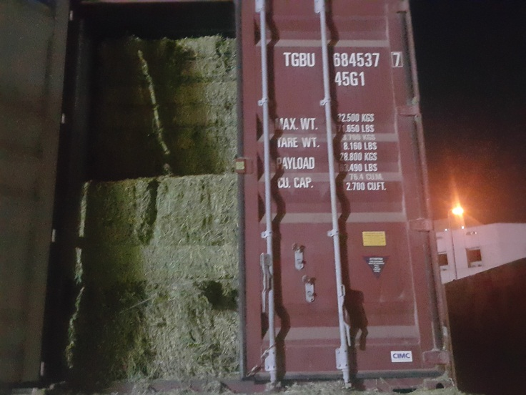  Finished loading with half door
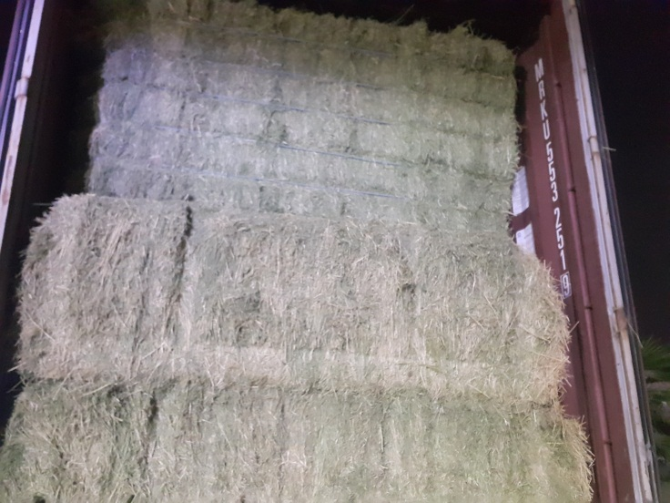  Finished Loading | 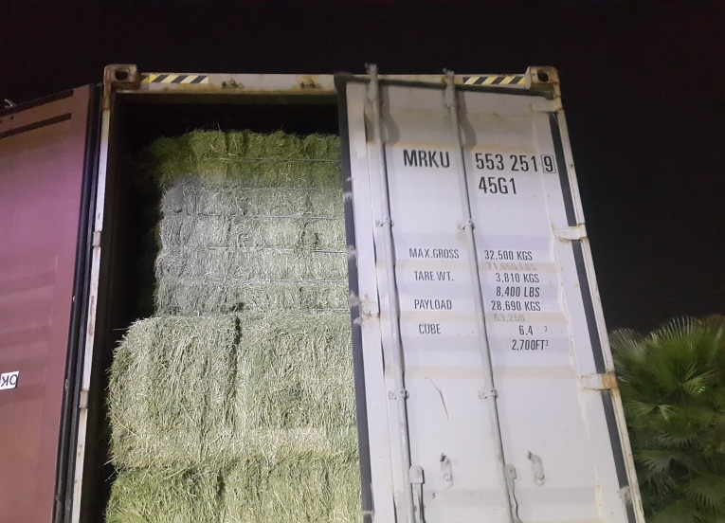  Finished loading with half door
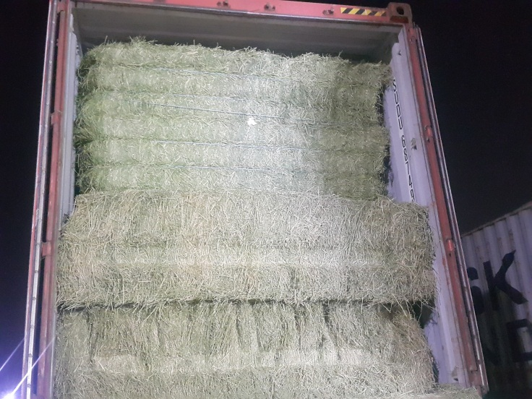  Finished Loading | 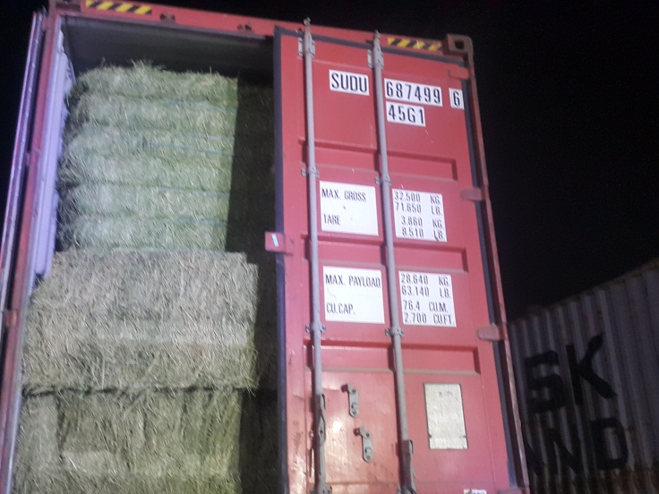  Finished loading with half door
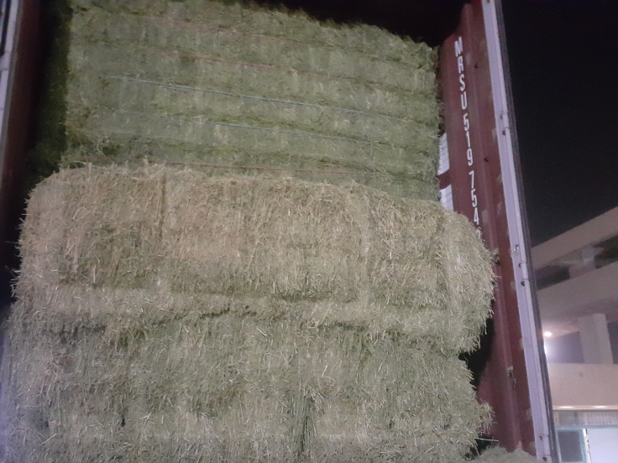  Finished Loading | 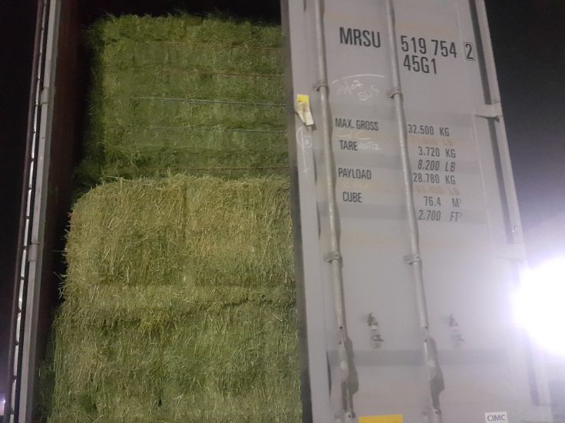  Finished loading with half door
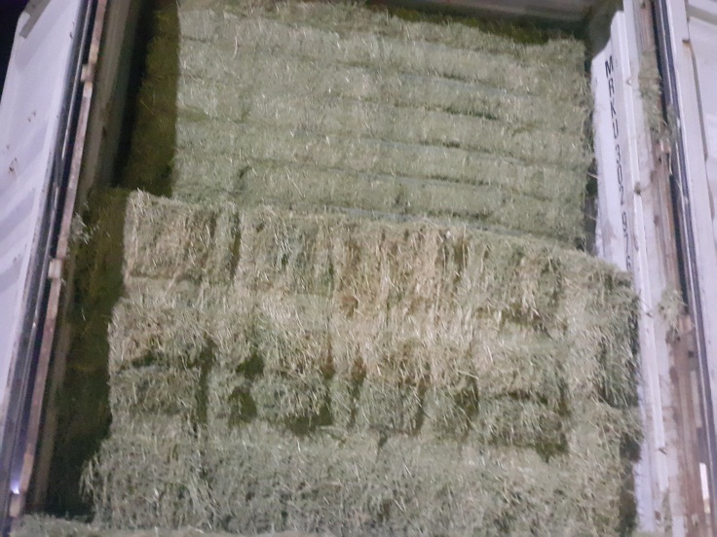  Finished Loading | 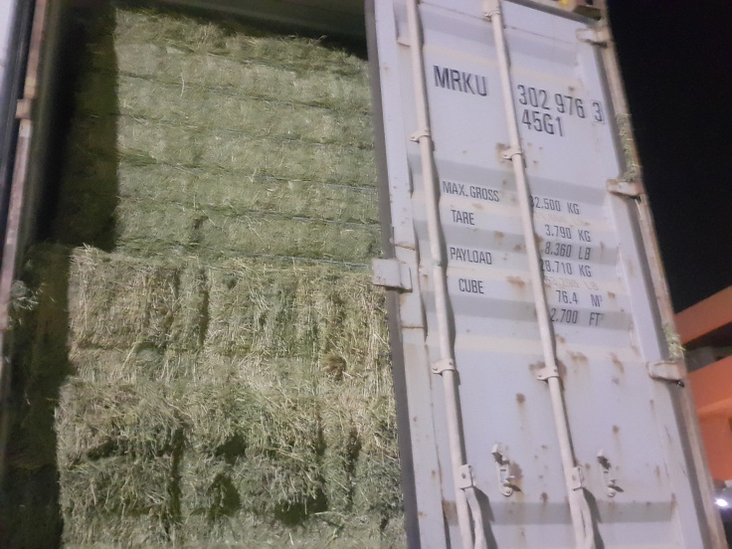  Finished loading with half door
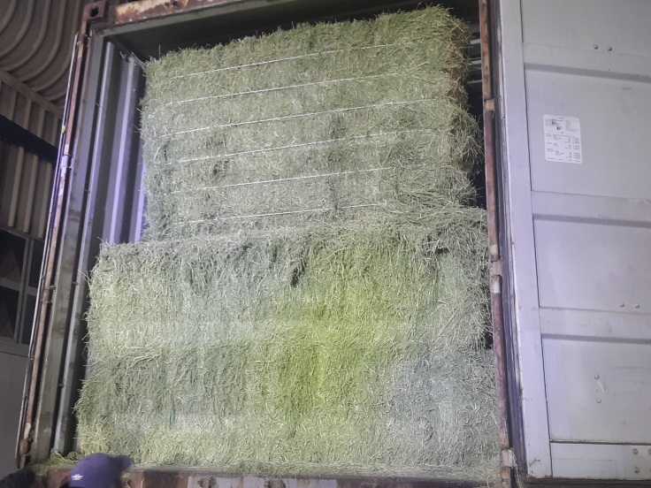  Finished Loading | 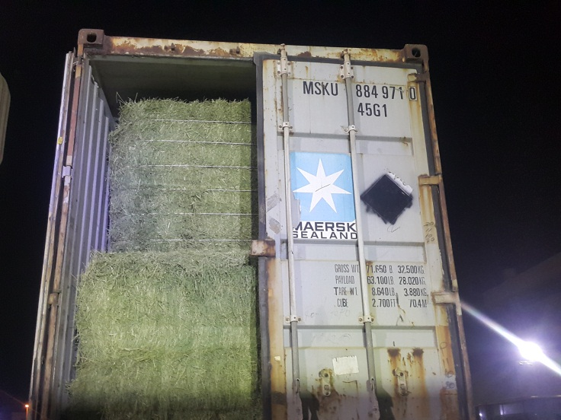  Finished loading with half door

Issued 14th of September 2023 by | SGS EGYPT LTD.
Natural Resources- Agri Commodities | Abdelhady Bayoumi

The findings of the stored Goods inspection contained herein (the “Findings”) strictly relate to and cover examination of part or parts of the Goods safely accessible for inspection in accordance with the client’s instructions. The Findings only relate to the time and place of inspection and do not constitute nor are intended to constitute evidence of the existence of part or all of the Goods prior to and after the time of inspection. SGS does not control the storage place of the Goods nor has any responsibility for the storage, custody and safety of the Goods. SGS does not guarantee nor make any representation about i) the accuracy and authenticity of the documents presented by the operator of the storage place (if any); ii) ownership of and title to the Goods; iii) quantity and quality of the Goods. SGS accepts no liability for the consequences of any action taken or not taken on the basis of this certificate/report.
This document is issued by the Company under its General Conditions of Service accessible at https://www.sgs.com/en/terms-and-conditions. Attention is drawn to the limitation of liability, indemnification and jurisdiction issues defined therein.
Any holder of this document is advised that information contained hereon reflects the Company’s findings at the time of its intervention only and within the limits of Client’s instructions, if any. The Company’s sole responsibility is to its Client and this document does not exonerate parties to a transaction from exercising all their rights and obligations under the transaction documents. Any unauthorized alteration, forgery or falsification of the content or appearance of this document is unlawful, and offenders may be prosecuted to the fullest extent of the law.
---------------------------------------------------------------------------End of Report---------------------------------------------------------------------------------

